|  |  |
| --- | --- |
|  | **Qatar University**  **College of Engineering**  **Department of Computer Science and Engineering** |

Senior Project Report

A Smart System for Detecting, Analyzing and Assessing Reckless Car Driving

**Project Group Members:**

Mareim Elsayem (201406303)

Somayya Elmoghazy (201406585)

Diana Al-Woraydat (201303328)

**Supervisor**: Dr. Abdulaziz Al-Ali

**Co-Supervisor**: Dr. Uvais Qidwai

**Spring 2018**

This project report is submitted to the Department of Computer Science and Engineering of Qatar University in partial fulfillment of the requirements of the Senior Project course.

Declaration

This report has not been submitted for any other degree at this or any other University. It is solely the work of us except where cited in the text or the Acknowledgements page. It describes work carried out by us for the capstone design project. We are aware of the university’s policy on plagiarism and the associated penalties and we declare that this report is the product of our own work.

Student: Mareim Elsayem Date: 27 May 2018

Signature:

Student: Somayya Elmoghazy Date: 27 May 2018

Signature:

Student: Diana AL-Woraydat Date: 27 May 2018

Signature:

Abstract

Reckless drivers continue to pose several threats on the roads. Governments and ministries are always applying policies and procedures to enforce safe driving. Examples of current law enforcement methods include stationary cameras used to detect over speeding, and passing red traffic lights. Despite these efforts, there are several reckless behaviors that remain undetected, such as sharp sudden turns, fast and frequent lane changes and speeding over speedbumps. This project aims to detect a number of such behaviors which typically consist of different patterns of speed and angles of car deviations.

Our proposal is composed of two modules, a Data Collecting Module (DCM) and a Data Analysis Module (DAM). The Data Collecting Module employs the use of a chip (Raspberry PI) that is placed inside the car and connected to a few motion-tracking sensors. These sensors collect the necessary data related to kinematics of the moving car including speed, acceleration, and path deviation. The data collected from the sensors is directly segmented and saved on the memory of the chip. Data from the chip is then sent to a connected DAM composed of a more powerful computer (Data Analysis Module). This system is initially trained to analyze and classify the collected patterns into reckless and safe events using machine learning algorithms. The analysis also involves identification of the event type as sharp turns, harsh speed bumps, sudden acceleration or deceleration. The chosen algorithms are selected based on its classification accuracy along with satisfying the requirements and constraints of the project. Another aspect of this project is a website that will allow end-users to monitor and track their driving behavior. It shows reckless driving behavior detected by our system.

Acknowledgment

We first thank Allah for giving us the needed inspiration for this project. He also provided us with strength and patience throughout this semester in order to finally finish our senior project. We send our love and appreciation to our parents whom we would not have reached this stage without them strengthening us along the way

We would like to express our sincere gratitude to Dr. Abdulaziz Al-Ali [our supervisor] who was constantly available for help and guidance throughout the whole semester. We would also like to express our deep appreciation to Dr. Uvais Qidawi [our co-supervisor], who provided us with the needed help and assisted us with especially the hardware part of our project.

We spread our thanks to many individuals who contributed in completing this part of our project. We thank Brigadier General Mohammed Marafih, Director of Engineering and Traffic Safety Department at the General Directorate of Traffic in Qatar who generously gave us his time to discuss the scope of our project here in Qatar. We would also like to express our gratitude to Engineer Shareif Saleh and to Majd Abdaljabar for their continuous support and guidance throughout the project.

Table of Contents

[1 Introduction and Motivation 11](#_Toc516328563)

[1.1 Problem statement 11](#_Toc516328564)

[1.1.1 Technical challenges: 13](#_Toc516328565)

[1.1.2 Non-technical challenges: 13](#_Toc516328566)

[1.2 Project significance 13](#_Toc516328567)

[1.3 Project objectives 19](#_Toc516328568)

[2 Background and related work 20](#_Toc516328569)

[2.1.1 Background 20](#_Toc516328570)

[2.1.2 Related work 21](#_Toc516328571)

[3 Requirements analysis 32](#_Toc516328572)

[3.1 Functional requirements 32](#_Toc516328573)

[3.2 Use Case Diagrams 33](#_Toc516328574)

[3.3 Design constraints 36](#_Toc516328575)

[3.4 Design standards 37](#_Toc516328576)

[3.5 Professional Code of Ethics 37](#_Toc516328577)

[3.6 Assumptions 38](#_Toc516328578)

[4 Solution design 38](#_Toc516328579)

[4.1 Overview 38](#_Toc516328580)

[4.2 Hardware/software used 39](#_Toc516328581)

[4.3 Hardware design 42](#_Toc516328582)

[4.3.1 Raspberry PI 43](#_Toc516328583)

[4.3.2 MPU-6050 Triple Axis Gyroscope & Accelerometer 45](#_Toc516328584)

[4.3.3 NEO5MV2 GPS Module 48](#_Toc516328585)

[4.3.4 Network 50](#_Toc516328586)

[4.4 Software design 51](#_Toc516328587)

[4.4.1 Classification 51](#_Toc516328588)

[5 Implementation 55](#_Toc516328589)

[5.1 Hardware Implementation 55](#_Toc516328590)

[5.1.1 Data Reading 57](#_Toc516328591)

[5.1.2 Segmentation Algorithm 60](#_Toc516328592)

[5.1.3 Feature Extraction 64](#_Toc516328593)

[5.1.4 Communication Protocol 64](#_Toc516328594)

[5.2 Software Implementation 66](#_Toc516328595)

[5.2.1 Classification 66](#_Toc516328596)

[5.2.2 Website 69](#_Toc516328597)

[6 Testing 72](#_Toc516328598)

[6.1.1 Triple Axis Accelerometer and Gyroscope: 72](#_Toc516328599)

[6.1.2 NEO 6MV2 GPS MODULE 78](#_Toc516328600)

[6.1.3 Segmentation: 80](#_Toc516328601)

[6.1.4 Classification: 81](#_Toc516328602)

[6.1.5 Integration Testing 82](#_Toc516328603)

[7 Evaluation of the impact of the engineered solution 88](#_Toc516328604)

[8 Conclusion 89](#_Toc516328605)

[9 Future work 90](#_Toc516328606)

[10 Student reflections 91](#_Toc516328607)

[10.1 Somayya Elmoghazy 91](#_Toc516328608)

[10.2 Mareim Elsayem 91](#_Toc516328609)

[10.3 Diana Alworaydat 92](#_Toc516328610)

[11 References 93](#_Toc516328611)

[12 Appendix A – Project Plan 95](#_Toc516328612)

[12.1 A.1. Project milestones 95](#_Toc516328613)

[12.2 A.2. Project timeline 97](#_Toc516328614)

[12.2.1 Phase1 97](#_Toc516328615)

[12.2.2 Phase2 97](#_Toc516328616)

[12.3 A.3. Anticipated risks 98](#_Toc516328617)

List of Figures

[Figure 1.1 Statistics from the Survey 12](#_Toc516327519)

[Figure 1.2 Statistics from the survey 15](#_Toc516327520)

[Figure 1.3 Statistics from the survey 16](#_Toc516327521)

[Figure 2.1 Applying the First Clustering Algorithm 23](#_Toc516327522)

[Figure 2.2 Applying the Second Clustering Algorithm 24](#_Toc516327523)

[Figure 2.3 Summary of the Overall Procedure Flow Diagram 24](#_Toc516327524)

[Figure 2.4 Relationship Between Speeds and Thresholds 27](#_Toc516327525)

[Figure 2.5 Comparison Between the Results of LP Filters and Kalman Filters 29](#_Toc516327526)

[Figure 2.6 Summary of the Results of Different Algorithms 31](#_Toc516327527)

[Figure 2.7 Detailed Summary of [11] results 31](#_Toc516327528)

[Figure 3.1 Raspberry Pi Use Case Diagram 34](#_Toc516327529)

[Figure 3.2 DAM Use Case Diagram 35](https://qucloud-my.sharepoint.com/personal/me1406303_qu_edu_qa/Documents/Senior%20project%20220/Senior%202/Project220-FinalReport-Dr.%20Abdulla%20comments.docx#_Toc516327530)

[Figure 4.1 High-Level Architecture 38](#_Toc516327531)

[Figure 4.2 System Flow 39](#_Toc516327532)

[Figure 4.3 spyder -The Scientific PYthon Development EnviRonment 40](#_Toc516327533)

[Figure 4.4 MATLAB 40](#_Toc516327534)

[Figure 4.5 WebStorm 40](#_Toc516327535)

[Figure 4.6 eclipse 40](#_Toc516327536)

[Figure 4.7 Triple Axis Gyroscope & Accelerometer Module 41](#_Toc516327537)

[Figure 4.8 Raspberry Pi 3 Official Desktop Starter Kit (16Gb, White) 41](#_Toc516327538)

[Figure 4.9 Waveshare NEO-7M-C (B) GPS Module 41](#_Toc516327539)

[Figure 4.10 D-Link AC1200 Wi-Fi Router 42](#_Toc516327540)

[Figure 4.11 Example of Segmentation Output 43](#_Toc516327541)

[Figure 4.12 Flowchart of Process inside the Raspberry Pi 44](#_Toc516327542)

[Figure 4.13 axis direction of accelerometer 45](#_Toc516327543)

[Figure 4.14 wiring diagram of raspberry pi and MPU6050 46](#_Toc516327544)

[Figure 4.15 wiring diagram of raspberry pi and NEO6MV2 49](#_Toc516327545)

[Figure 4.16 output of “cgps -s” command 50](#_Toc516327546)

[Figure 4.17 Network Diagram 51](#_Toc516327547)

[Figure 4.18 Classification layers 54](#_Toc516327548)

[Figure 5.1 Wiring Diagram 56](#_Toc516327549)

[Figure 5.2 Overview of DCM Functionality 57](#_Toc516327550)

[Figure 5.3 Pseudocode of Segmentation Algorithm 60](#_Toc516327551)

[Figure 5.4 Flowchart of Segmentation Algorithm 61](#_Toc516327552)

[Figure 5.5 Segmentation Results of python code 62](#_Toc516327553)

[Figure 5.6 Segmentation Results of python code 63](#_Toc516327554)

[Figure 5.7 Segmentation Results of matlab code 63](#_Toc516327555)

[Figure 5.8 Segmentation Results of matlab code 64](#_Toc516327556)

[Figure 5.9 Successful Authentication 66](#_Toc516327557)

[Figure 5.10 Failed Authentication 66](#_Toc516327558)

[Figure 5.11 features of 10 driving examples 67](#_Toc516327559)

[Figure 5.12 Home Page 69](#_Toc516327560)

[Figure 5.13 login page 70](#_Toc516327561)

[Figure 5.14 events page 70](#_Toc516327562)

[Figure 5.15 classification results 71](#_Toc516327563)

[Figure 5.16 events page 71](#_Toc516327564)

[Figure 5.17 google maps to show the location 72](#_Toc516327565)

[Figure 6.1 Accelerometer and Gyroscope data of Reckless Right Turn 1 73](#_Toc516327566)

[Figure 6.2 x-axis Accelerometer data of Reckless Right Turn 1 74](#_Toc516327567)

[Figure 6.3 Accelerometer and Gyroscope data of Left Turn 1 75](#_Toc516327568)

[Figure 6.4 x-axis Accelerometer signal of Left Turn 1 75](#_Toc516327569)

[Figure 6.5 Accelerometer and Gyroscope data of Reckless Sudden brake 1 76](#_Toc516327570)

[Figure 6.6 Y-axis Accelerometer signal for Sudden Brake 1 76](#_Toc516327571)

[Figure 6.7 Accelerometer and Gyroscope data for Reckless speed Bump 1 77](#_Toc516327572)

[Figure 6.8 Z-axis Accelerometer signal for Reckless Speed Bump 1 78](#_Toc516327573)

[Figure 6.9 Segmentation on x-axis 82](#_Toc516327574)

[Figure 6.10 Segmentation on y-axis 83](#_Toc516327575)

[Figure 6.11 Segmentation on z-axis 83](#_Toc516327576)

[Figure 6.12 Screenshot of classifier output 85](#_Toc516327577)

[Figure 6.13 Sample of Features Extracted 87](https://qucloud-my.sharepoint.com/personal/me1406303_qu_edu_qa/Documents/Senior%20project%20220/Senior%202/Project220-FinalReport-Dr.%20Abdulla%20comments.docx#_Toc516327578)

List of tables

[Table 2.1 Summary of Results of [5] 21](#_Toc516328081)

[Table 2.2 Summary of Results of [7] 25](#_Toc516328082)

[Table 2.3 Summary of Sensors Used in All Related Work 32](#_Toc516328083)

[Table 2.4 Summary of Algorithms Used in All Related Work 32](#_Toc516328084)

[Table 3.1 Use Cases and Description 33](#_Toc516328085)

[Table 3.2 Technical design constraints 36](#_Toc516328086)

[Table 3.3 Practical design constraints 36](#_Toc516328087)

[Table 3.4 Design Standards 37](#_Toc516328088)

[Table 3.5 Code of Ethics 37](#_Toc516328089)

[Table 4.1 Software/ Hardware Used 39](#_Toc516328090)

[Table 4.2 movements and the changes in each axis 46](#_Toc516328091)

[Table 4.3 Electrical connections between raspberry pi and MPU6050 47](#_Toc516328092)

[Table 4.4 Electrical connections between raspberry pi and NEO6MV2 48](#_Toc516328093)

[Table 4.5 Machine learning Algorithms Accuracies 52](#_Toc516328094)

[Table 4.6 Multilayer perceptron Event Accuracies 52](#_Toc516328095)

[Table 4.7 Multiclass Vs Binary Classification accuracies 53](#_Toc516328096)

[Table 4.8 Confusion Matrix 55](#_Toc516328097)

[Table 5.1 Theory Vs Time series Events 58](#_Toc516328098)

[Table 5.2 Events Feature 64](#_Toc516328099)

[Table 5.3 splitting Dataset results 67](#_Toc516328100)

[Table 5.4 SVM Left Turns Performance 68](#_Toc516328101)

[Table 5.5 RF Left Turns Performance 68](#_Toc516328102)

[Table 5.6 MLP Left Turns performance 68](#_Toc516328103)

[Table 6.1 Right turn events 73](#_Toc516328104)

[Table 6.2 Left Turn 74](#_Toc516328105)

[Table 6.3 Sudden Brake 76](#_Toc516328106)

[Table 6.4 speed bumps 77](#_Toc516328107)

[Table 6.5 MLP testing of NEO6MV2 GPS 79](#_Toc516328108)

[Table 6.6 Segmentation Tests 80](#_Toc516328109)

[Table 6.7 Event type Classifiers Output Vs Actual Event 81](#_Toc516328110)

[Table 6.8 Reckless/ safe Classifiers output Vs Actual Event 81](#_Toc516328111)

[Table 6.9 Testing Results 84](#_Toc516328112)

[Table 6.10 sample of recorded data 87](#_Toc516328113)

[Table 7.1 Evaluation of the impact of the Engineered Solution 88](#_Toc516328114)

[Table 12.1 Risks and Contingency Plans 98](#_Toc516328115)

|  |  |
| --- | --- |
| **Acronyms**  DCM  DAM | **Definition**  Data Collection Module  Data Analysis Module |
| IMU | Inertial Measurement Unit |
| GPS | Global Positioning System |
| DC | Direct Current |
| SVM | Support Vector Machine |
| LP | Low-pass |
| TAD | Topological Anomaly Detection |
| Alat | Lateral Acceleration |
| Alon | Longitudinal Acceleration |
| EMA | Exponential Moving Average |
| CAN-bus | Controller Area Network |
| MAD | Maneuver boundary Detection system |
| MLA | Machine Learning Algorithm |
| RBF Network | Radial Basis Function Network |
| C4.5 | Decision Tree Induction Algorithm |
| K-NN | K-nearest Neighbors Algorithm |
| IEEE | Institute of Electrical and Electronics Engineers |
| IDE | Integrated Development Environment |
| OBD | On-Board Diagnostic |
| ANN | Artificial Neural Network |
| MLP | Multilayer Perceptron |
| RF | Random Forest |

# Introduction and Motivation

## Problem statement

Reckless Driving is not confined to exceeding the speed limit, overtaking from the right, or passing the red traffic signals. There are other types of violations that happen frequently in the roads that jeopardizes the lives of people. However, safety rules are not taking them into account. These are, fast and frequent changing of lanes, sharp turns, driving too fast on speed bumps, and sudden brakes. A question answered by 256 persons, proves that some real reckless behaviors are not taken seriously into consideration by the current rules and regulations Figure1.1. These types of violations are proven to have serious impact on people inside and outside the car. Nevertheless, these events cannot be reported using the current used tools such as radars and camera. Radars are limited to reporting speeding violations in a certain area of a road, cameras are used for security purposes, and usually employed in case of a formal complaint. Thus, police officers sometimes roam the streets to report these violations manually which is considered impractical and inefficient since people tend to drive safely in front of policemen. Hence, there is an urgent need for a system that is able to detect these behaviors. A system that can read cars kinematics and be able to relate them to a certain type of event. Then decide if that event is reckless or not.

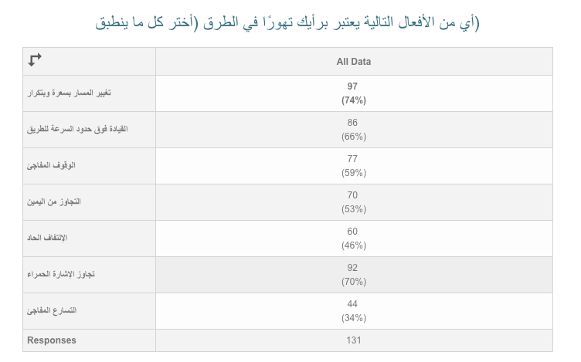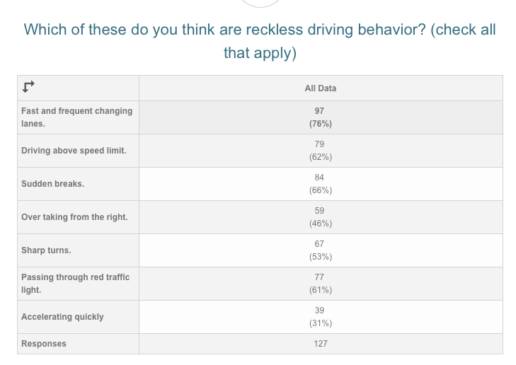

Figure 1.1 Statistics from the Survey

Our project will be able to detect several reckless behaviors such as sudden brakes, approaching speed bumps with high speed, and sharp turns. Detecting such behaviors would definitely help classify a driver as reckless or safe since that device is designed to be present in the vehicle at all times.

### Technical challenges:

* The solution relies on having large number of different data samples to ensure results accuracy.
* Differentiating between some events type is challenging.
* Transmitting data from the DCM to the DAM may take time especially when transmitting data for long trips.
* Choosing the most convenient Artificial intelligence algorithm to be implemented in the system.

### Non-technical challenges:

1. Recklessness scale in many cases can be subjective and varies from one person to another.
2. Collecting primary reckless data for analyzing and testing is a costly process and can be dangerous in many cases.
3. Volunteers are needed to record different patterns of driving.

## Project significance

According to ASIRT (Association for Safe International Road Travel), road accidents are the main reason of death among young people ages 5-29. On average, over 1,000 persons under 25 die on the road on daily basis. That is almost 400,000 yearly [1]. A report released by Qatar’s Ministry of Interior in 2016 stated that half of car accidents happened due to negligence and recklessness behavior. In fact, such behavior caused 388 major accidents and 2228 minor ones in that year [2].

Moreover, the Brigadier General Mohammed Marafih, Director of Engineering and Traffic Safety Department at the General Directorate of Traffic in Qatar, said in our interview, “traffic rules are ineffective to the needed extent. On the one hand, cameras and radars could be circumvented by people. On the other hand, methods that rely on the human element, where police officers are responsible for taking fines manually, are ineffective since people tend to act normally when a police officer is present on the road”.

Accordingly, there are several reckless driving behaviors that remain undetected under the implemented law enforcement methods in Qatar. This may be why reckless driving is still a major issue in the country. In our survey we targeted two different groups of people mainly based on their age. We made a survey, which got 284 responses. The majority of people agreed that reckless driving is still a major problem faced by the people in Qatar. Responses are displayed in Figure 1.2 below.

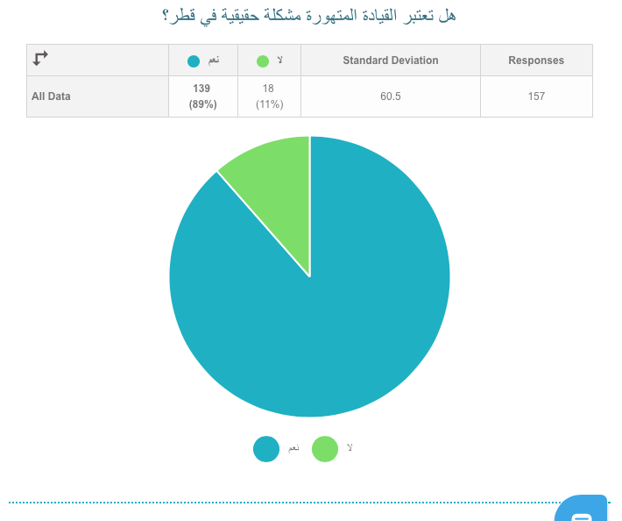

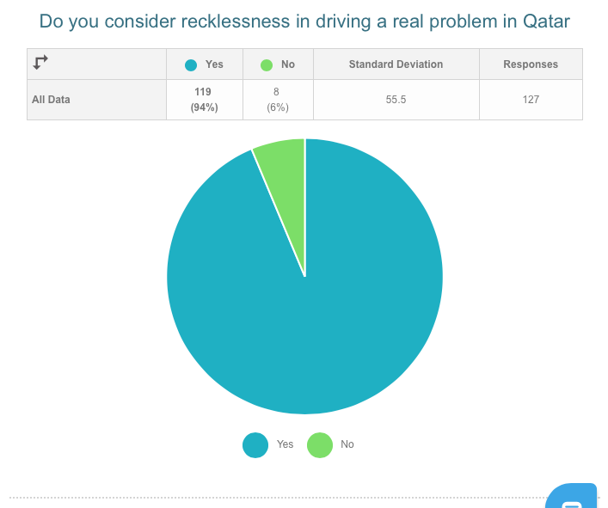

Figure 1.2 Statistics from the survey

We also investigated whether the driving regulations are enough to ensure safety on the roads in Qatar. There are four possible answers for this question in our survey. The answers are shown in Figure 1.3 below. People might have thought that by answering this question, more regulations will be added and accordingly more fines. Moreover, people might not be aware of how dangerous the reckless actions that are not easily caught by the current regulations could be.

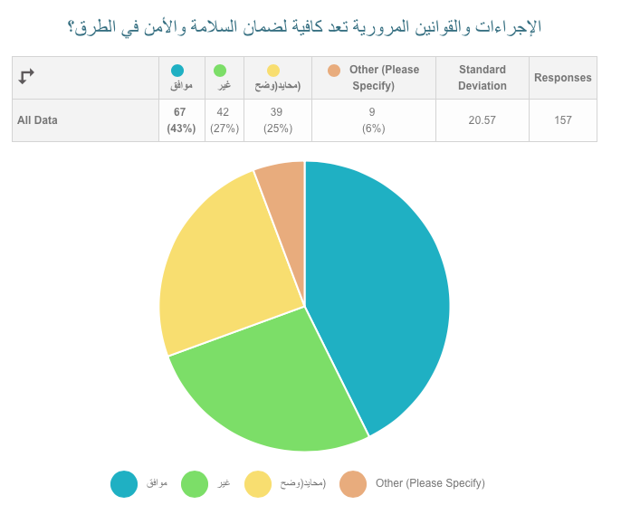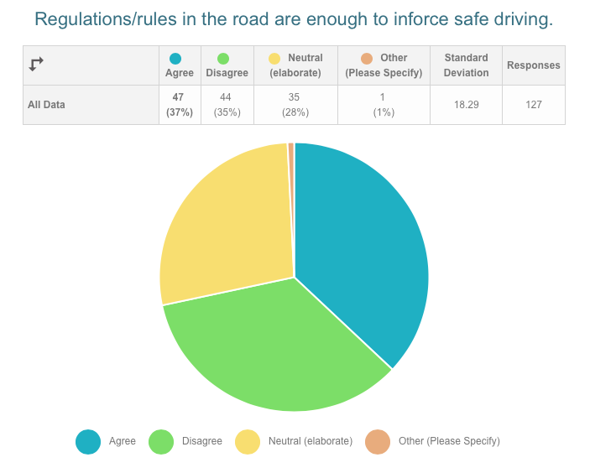

Figure 1.3 Statistics from the survey

Ensuring that drivers are always safe is sometimes a vital issue when there are human lives involved. Institutions that provide transportation such as schools and universities are responsible for the lives of the passengers, and that means they need to keep track of the driving behaviors of their drivers. In our survey, bus drivers were ranked as the highest reckless drivers in Doha Figure 1.4. This opens our eyes to the fact that our children may not be safe during their commute to schools. In addition to buses, many families find it necessary to employ personal drivers. In doing so, they are accepting the possible risk of reckless driving behavior from employed drivers. These drivers may put the lives of their passengers in danger, especially those who are not aware of the road regulations, or may not be able to voice their concerns, such as children and elders. In addition to passengers’ safety concerns, personal drivers usually drive vehicles they do not own, which could be damaged if they are careless in their driving.

Figure 1.4 bellow show the ranking of the reckless drivers according to the responders of both surveys. The higher ranking reckless drivers get higher scores. For example, the highest ranking reckless drivers in both surveys are school/ university buses with scores of 3.4 out of the 4 options and 3.63, with 4 being the most reckless and 0 being the least reckless. In the second place come trucks in the English survey (score: 3.45) and personal drivers in the Arabic survey (score: 3.5).

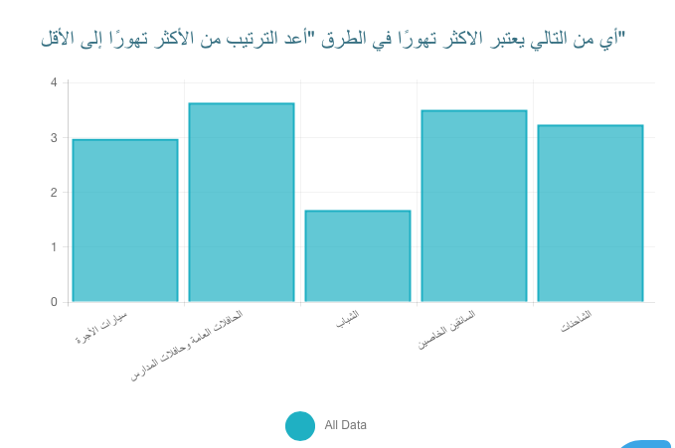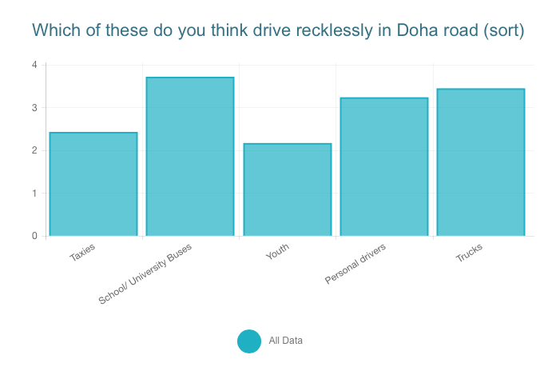

Figure 1.4 Statistics from Survey

This project can also be used by taxi services in Qatar. Normally, these services rely on passengers’ ratings to the drivers to ensure better experiences. These ratings don’t necessarily mean safe driving. For example, they can be a result of kind treatment from the driver. This can also be seen in the above figures were taxis were ranked either the second or third most reckless by our responders. Accordingly, when these services employ our project, they can increase the safety of their drivers, reduce taxi accidents, and also gain better (or more) trust from their customers.

Reckless driving is one of the most serious problems in Qatar. Since all of us drive, we experience this problem nearly every day. Thus, we decided to contribute our project towards the resolution of this problem. Moreover, we wanted to learn something new and different from what we have been studying. Machine learning is one of the hot topics in the technology field and one that is not being taught to us. Our interest in the machine learning field along with the desire to spread safe driving behaviors are the motives behind the idea of this project. The fact that there is so much research going on in machine learning will enable us to continue this project even after graduation. Not only will we find innovative ways to improve this project, we will also have a strong experience with machine learning that will create several opportunities for us in the future to work on different projects.

## Project objectives

1. To implement a system that is able to detect reckless driving behavior using data collection and data analysis modules.
2. To use Triple Axis Gyroscope & Accelerometer Modules and GPS to collect driving data.
3. To use a raspberry PI in collecting data from used sensors, and segment the data where events are detected, then send segmented events to the Data Analysis Module.
4. To design and implement a Data Analysis Module that is able to receive data within an acceptable time and process it.
5. To design an algorithm in the Data Analysis Module that is able to categorize events into specific types and then detect whether they were reckless or not.
6. To design a website that is able to show trip’s statistics.

# Background and related work

### Background

No one can deny that driving accidents take a noticeable place over the death rates causes all over the world. In a concentrated view over our daily life, [3] mentioned that “*Qatar driving can be intimidating, frustrating and even dangerous*”. Governments and ministries are always applying policies and regulations to enforce safe driving and prevent people from breaking the rules. In some countries, these regulations are more effective than in others. Some of these policies are increasing the number of speed radars, cameras that are installed on traffic lights and intersections, fines and impound a vehicle in some cases [3]. Moreover, policies also include police officers who roam the roads in undercover cars to catch reckless drivers who break these rules and are not in sight of the installed cameras on the roads. For example, in Qatar, “*Traffic regulations have been incredibly lax in Qatar over the years, in 2007, due to the high accident rate, have Qatari police become more rigorous*” [4].

Another method Qatar used to reduce reckless behavior is using mobile radar cameras and video cameras fitted in mobile roamed unmarked cars [3]. However, the problem of reckless behaviors that remain undetected still stands.

For this reason, there have been many attempts to monitor the driving behaviors of the full trips done by drivers. This way, all reckless events are recorded, and necessary regulations can be applied. This is specifically useful for institutions that provide drivers for taxis, school buses, or any other form of transport where drivers need to strictly follow the safety procedures. Existing approaches from the literature review use different sensors that are typically installed inside the car. The used sensors include accelerometers, gyroscopes, magnetometer and GPS to record the movement of the car. The gathered data is processed later to identify different driving events. The processing of data mostly requires a pre-processing stage to isolate only the event. This process is called segmentation where takes the collected time series data and breaks it into either equal size windows or segments where only events occur. Generally, researchers analyze the data collected with reference to two main cases, one is to an established physical model that identifies reckless behaviors based on subjective physical equations. Alternatively, other approaches use different machine learning algorithms to identify these events.Such approach can also be used to spread awareness of the consequences of reckless driving and how even the smallest acts can have horrific impacts on other peoples’ lives.

### Related work

#### Portable Reckless Driving Detection System

[5] used uses a 2-axis accelerometer connected to a 16F877 microcontroller to collect x and y time series data. It used the data to detect three events of bus drivers which are harsh forwards, sudden brakes, and quick turns. The accelerometer is fixed somewhere at the back of the driver’s seat. [5] then scores the reckless event using a fuzzy logic rule.

For preprocessing, [5] applies high-pass Butter-worth filter to remove the DC offset, and a low pass filter to remove the jittering noise. After that, it applies a rule-based model to identify the events based on multiple trials and errors the results they got are shown below in Table 1. To score the events, [5] uses Mamdani mean inference and the centroid de-fuzzification method.

After taking 11 volunteers in a bus to score driving event happening in a certain time from 1 to 10. The average of the normalized score is calculated and compared to the output score from the system. The output compared between the fuzzy system and the average score from volunteers and is summarized in Table 1 below.

Table 2.1 Summary of Results of [5]

|  |  |  |
| --- | --- | --- |
| Event | Accuracy | Error |
| Taking off | 88.04% | 11.96% |
| Brake | 87.21% | 12.79% |
| Turning right | 88.84% | 11.16% |
| Turning left | 84.36% | 15.64% |

The paper presented a detection system with good accuracies using portable sensors. However, it relies heavily on trial and error in defining thresholds and classifying events. Moreover, 11 volunteers are not enough to evaluate the system’s classifications.

#### Unsupervised Driving Performance Assessment using Free-Positioned Smartphones in Vehicles

[6] proposes a study of a coordinate transformation technique; to perform coordinate transformation and axis alignment for IMU and GPS data collected from free-positioned smartphones. The project employs aligned data to detect reckless driving behavior using unsupervised algorithm. It employs the use of smartphone GPS to indicate the occurrence of driving events such as acceleration, brake, turns, and forward driving. It also uses the smartphone’s inertial measurement unit (IMU) to collect the lateral, longitudinal, and vertical acceleration and rotations of a vehicle.

The proposed solution is [6] is based on two assumptions:

1. Safe, or convenient driving behavior should be reflected with the stable, steady, or low variance of vehicular dynamical performance.
2. An experienced driver should act as “good driving” for most of the time, whereas “bad driving” may occur at a limited number of moments

For preprocessing, a median filter is employed to filter out noise from accelerometer and gyroscope data. To process the data, [6] applies different stages to get the desired results based on the state of the smartphone. The final stage that is reached regardless of the state of the smartphone is the driving assessment stage. If the smartphone is fixed inside the car with a known pose, but the phone axis reference is different from the car reference one prior process is applied. This process computes the car-referenced accelerations. The algorithm computes 3 matrices for transformation each is a result of a rotation about one of the axes.

In another scenario, if the phone is not fixed inside the car and the pose of the phone is unknown, an axis alignment step prior to coordinate transformation is applied. After that, the data will be ready for the driving assessment stage.

The driving assessment in this paper is done in four stages. The first of which is feature extraction where the data is divided into a fixed length window of 1 second. The second stage is event identification where GPS is used to detect the events not the IMU. the peak of the speed derivative indicates a brake, while the GPS bearing derivatives indicate turns. The third stage is the clustering-outliers where the driving features of the experienced drivers’ data is extracted and classified as safe. Then a clustering scheme is applied three times.

Two unsupervised clustering models are used:

1. One-Class SVM: captures the shape of the dataset and separates non-linear scaled layers after iteration.
2. Topological Anomaly Detection (TAD): computes the distance between nearest neighbors, to generate the layers.

Applying these model results in one inner layer (safe) and three layers of outliers (reckless). Layers are labeled from A to D (from innermost to outermost).  With “A” being the closes to the safe driving (innermost layer), and “D” being the most reckless (outermost layer). The intersection of outermost anomalies obtained from different clusters can be recognized as “well accepted” risky events.

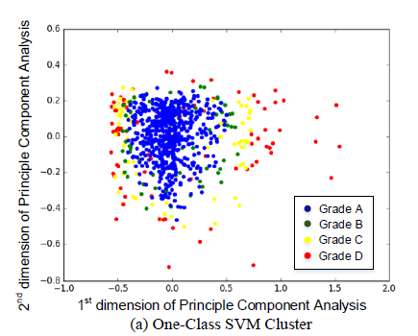

Figure 2.1 Applying the First Clustering Algorithm

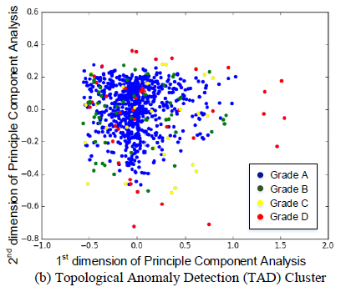

Figure 2.2 Applying the Second Clustering Algorithm

The results in [6] are graded based on the results of the two clustering algorithms. Each event is graded with “A”, “B”, “C”, or “D”. When an intersection between two algorithms is found, then “Grade Point Average (GPA)”is calculated for each driver using the standard college grade formula to find the overall performance.

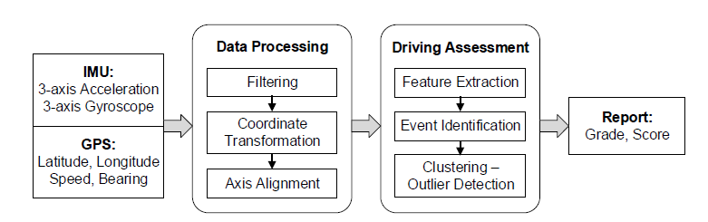

Figure 2.3 Summary of the Overall Procedure Flow Diagram

This paper was able after data processing, feature extraction, and event identification to cluster driving behaviors using unsupervised machine learning. Based on the assumption that experienced drivers drive safe most of the time, and hence their behavior is considered as the inner layer of the clustering scheme.

#### Mobile phone based on drunk driving detection

[7] aims to detect some drunk driving behaviors using mobile phone application. These behaviors are categorized into two main categories:

1. Lane Position Maintenance (curvilinear movements), such as weaving, drifting, swerving and turning with a wide radius

Speed Control in Driving, such as abrupt acceleration or deceleration, erratic braking and jerky stop.

This mobile application is designed on an android G1 phone, with the use of some mobile phone sensors and an alert notification system to notify the driver or call police. The sensors used on the phone are accelerometer, which collects Realtime data of acceleration in the X, Y, and Z axis, and the orientation sensor, which collects Realtime data of the rotation angles in the X, Y, and Z axis.

In [7] the state of the car is monitored so to start the application when the car starts moving. Moreover, calibration techniques are employed if the position of the phone is changed to determine the 3-axis of multiple positions of the mobile phone using orientation angles around X, Y and Z axis. Data collected is then processed to get Alat (lateral acceleration) and Alon (longitudinal acceleration), then use them to categorize events based on **matching pattern**.

* Lateral Acceleration Pattern Matching for Lane Position Maintenance events:

Within a time-window of 5 seconds, the difference between maximum and minimum Alat is counted, if it exceeded the threshold then there is a Lane Position Maintenance problem.

* Longitudinal Acceleration Pattern Matching for Speed Control events:

Within a time-window of 5 seconds maximum and minimum values of Alon are compared to one of two threshold values one is positive (thlog+) and the other is negative (thlog-).

Values of threshold were put based on trails of the tested data.

The results in [7] were collected based on 72 sets of drunk driving behaviors and 22 sets of regular driving behaviors.

Table 2.2 Summary of Results of [7]

|  |  |  |  |
| --- | --- | --- | --- |
|  | Behavior | False Negative (FN) | False Positive (FP) |
| Phone Not Sliding | curvilinear movements | 0 % | 0.49% |
|  | speed control problems. | 0 % | 2.39% |
| Phone Slides During the Trip | curvilinear movements | 14.28% | 1.09% |
| speed control problems. | 0 % | 2.72% |

**Note**: False Negative is when drunk driving behaviors occurred, but the device missed them. However, False Positive when the device reports drunk driving related behaviors, but the vehicle is under regular driving conditions.

Accordingly, the performance of the system is very well when there is no sliding of the phone while driving. However, the values of these errors increase when the phone slides and accuracy of the system decrease. In addition to the accuracy problem, the battery performance of the mobile phone decreases with the usage if this system.

#### Combining speed and acceleration to detect reckless driving in the informal public transport industry

[8] aims to monitor some reckless driving behaviors of minibus using erratic driving detection system based on usage of accelerometer and GPS, these behaviors are categorized into two main categories, urban events such as a pull-over, sharp turn or sharp braking and highway events such as circular curve, such as swerving and sharp braking.

They proposed two models. One is gauging recklessness from a passenger’s perspective and the other is based on civil engineering principles.

Data collected from the accelerometer is recorded on the SD-card used in the prototype. The data is then processed using MATLAB. An exponential moving average (EMA) low-pass filter is applied to remove the engine noise and other high frequencies without affecting the relevant data. After the filtering, thresholds are determined based on the speed value and all acceleration peaks are compared with that thresholds. A peak implies to sudden and erratic driving maneuvers and so it is not safe. The erratic acceleration thresholds are categorized into six different thresholds. The main idea that the threshold determination is based on an assumption that the threshold decreases when the speed increases. The following table shows the values of threshold and their correspondence speed values.

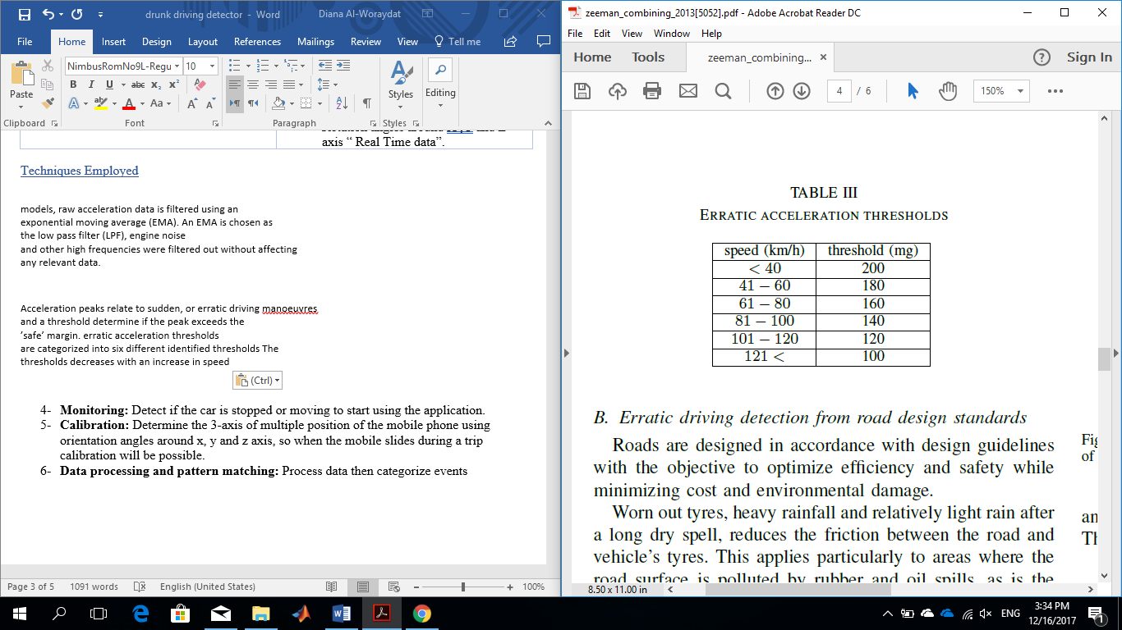

Figure 2.4 Relationship Between Speeds and Thresholds

To test this model, acceleration data of 36 hours from 41 minibus taxis were collected and processed, this system was able to clearly distinguish between normal driving and erratic driving.

#### Automatic Maneuver Boundary Detection System for Naturalistic Driving Massive Corpora

[9] aims to distinguish between the straight and non-straight maneuvers by recognizing and analyzing some vehicle related signals. The signals are acceleration data in the X, Y, and Z axis extracted from CAN-bus and rotation angles around the three-axis extracted from a smart portable device (gyroscope). This system is called Automatic Maneuver Boundary Detection system (MAD).

In this system lateral vehicle dynamic variations and steering wheel angle variations are analyzed to evaluate and compare performance of the maneuver boundary detection algorithm.

The data collected is filtered using FilterBank analysis. A threshold is then set on the computed FilterBank energies to classify different regions of the steering wheel angle signal into straight or non-straight. For testing, a base is set to compare with. To set the base, the instrumented vehicle (CAN-bus) and the portable device (gyroscope) are places in the car and the output data is extracted, then the average response is computed. That average response is used as base data, UTDrive corpus. After that, multiple transcribers asked to transcribe different maneuver boundaries of UTDrive corpus, then compare the result with the base. Similarly, a single novice transcriber asked to transcribe different maneuver boundaries of UTDrive corpus, then compare the result with the base.

The results in [9] were collected based on recordings from 16 driving sessions using both CAN-bus and the gyroscope. Moreover, 62 driving sessions are recorded from UTDrive corpus.

MAD tool successfully identified maneuvers and marked their boundaries with 99% accuracy. It was able to detect boundaries that were missed by the human transcribers, and this means that human transcription is disposed to errors.

This paper presented a solution with a high level of accuracy. However, people can hardly access the information of the CAN bus. The access is obtained through the On-Board Diagnostic (OBD) port of vehicles, which is based on a private protocol the automobile manufacturers are reluctant to release. This reluctance is due to security and safety reasons. Moreover, a study showed that several of the vehicle components can be access through OBD [16]. Such revelation could threaten the vehicle or the humans.

#### Safe Driving Using Mobile Phones

In [10], a smartphone is placed in the car and used to analyze and advise on three safety conditions. One is vehicle’s safety conditions, where gear shift speed is obtained from smartphone’s accelerometer and used later to alert drivers before reaching that speed that may result in a gear shift. Another safety condition is driving patterns, where they studied acceleration, deceleration, and lane changes. By applying threshold, they were capable of distinguishing between safe and extreme events. The third safe condition is road safety. Bumps and pothole are identified through detecting events on the z-axis of accelerometers and GPS is used to locate the event location.

The project proposed a way of evaluating some driving behavior (aggressive or safe) using a threshold for each type of event, but was not able to propose a method of identifying the event type. Used phone should be fixed and located in one of the proposed location, otherwise the system is not able to do axis transformation. All data recognized by the mobile is stored on the phone, and the user is granted to delete the data.

#### A Novel Model-Based Driving Behavior Recognition System Using Motion Sensors

[11] The main idea is to develop a driving behavior recognition system using three components: a theoretical physical model to represent the data change rule, motion sensor to gather data about the behavior of the driving, and a software component to handle the acquired data. [11] uses iNemo V2 chip to collect for three-axis accelerometer, three-axis gyroscope, and 3-axis magnetometer time series data. The sampling frequency of the hardware is 50 Hz.

The physical model is established before the start of the data acquisition. [11] studies the theory of rigid-body dynamics and the analysis of car motion to build the theoretical physical model. It analyzes the relationship between acceleration and linear velocity and that between linear velocity and linear velocity. It also studies magnetic induction intensity variation.

$$\vec{v_{t}}=\vec{v_{0}}+\vec{a}t \\ \vec{v}=\vec{w}×\vec{r}$$

The motion sensors then gather the required data to establish the dataset. [11] used the data of five drivers driving five different types of cars.

##### The data collected then enters three stages of processing:

Data Filtering Module: This stage aims to eliminate the noise existing in the sensors’ data. [11] proved that Kalman filters perform better than traditional low-pass filters in removing vibration noises and Gaussian noise

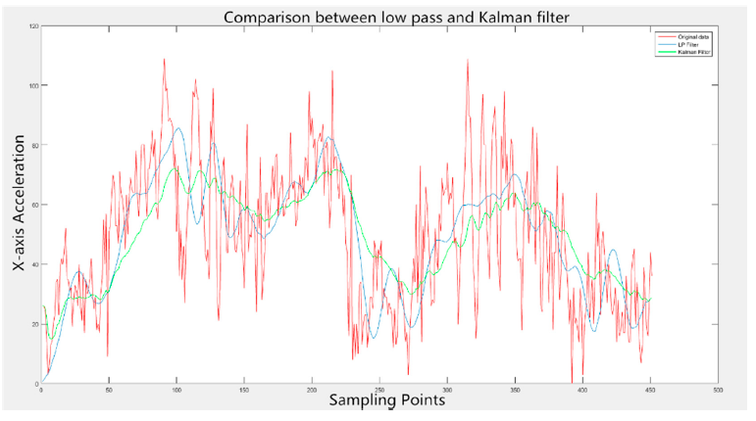

Figure 2.5 Comparison Between the Results of LP Filters and Kalman Filters

**Adaptive processing:**

This stage is for extracting physical data and features. Features include mean value, peaks, covariance… etc. [11] uses indefinite number of basic time windows, 0.25 seconds each covering 10 samples. The window determines the start and end points of valid data. [11] employs three different methods to identify the endpoints of an event:

Gradient Discrimination:

An event is represented by a change in the data which will cause a change in the slope. The paper calculates the slope of the time window (G) and compares it with a set a threshold for the calculated slope (Gt). The G>Gt, the data is reserved.

$$G=\left|\frac{\left(d\left(x+k-1\right)-d\left(x\right)\right)}{k-2×\left(sp-1\right)}\right|$$

In this figure, k is the number of sampling points in the basic time window. And d (x + k- 1) and d (x) respectively represent the calculated endpoints.

**Comparison between endpoints and mean value:**

The mean value of the data in the time window is calculated (m) as well as the mean of the first three starting points(ms) and the three ending points(me). if (m>ms & m>me) or (m<ms & m<me), the data in the basic time window is reserved.

Calculate energy of the data in the time window

The paper calculates the energy of the time window (E) and compares it with a set a threshold for the calculated slope (Et). The E>Et, the data is reserved.

$$E=\frac{g_{x}^{2}\left(i\right)+g_{x}^{2}\left(i-1\right)+…+g_{x}^{2}\left(i-k-1\right)}{k}$$

In this figure, gx (i) , gx (i - 1) , . . . , gx (i - k - 1) represent all the k sampling points in the basic window.

If none of the above conditions is satisfied, the data in the time window is discarded.

Innovatively, the physical model makes it possible to avoid the traditional approach of selecting

the most discriminative features

##### Feature Extraction:

[11] extracts eleven data features to use for classification. It claims that the physical model enabled them to choose only the most discriminative features of each event from the original set.

##### Pattern Recognition Module:

[11] employed different machine learning algorithms for event classification. A summary of the results of each algorithm is listed in Figure 2.6. A detailed summary for each event under each algorithm is shown in Figure 2.7, where the aggressive events are the ones whose labels start with the letter “A”.

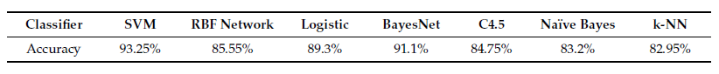

Figure 2.6 Summary of the Results of Different Algorithms

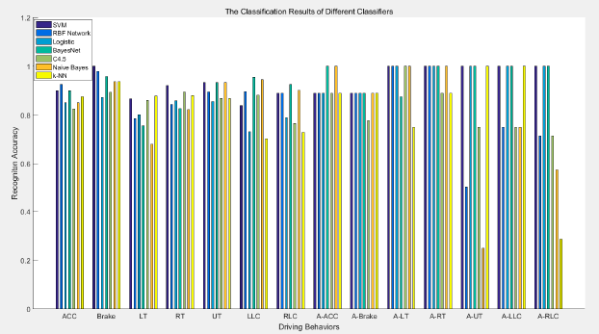

Figure 2.7 Detailed Summary of [11] results

This paper presented a comprehensive study of driving behavior categorization using different machine learning algorithms. However, areas of optimization still exist since it is mentioned there that their dataset was not ideal. Moreover, there is still room for deeper feature extraction which can improve the accuracy of the employed machine learning algorithms.

Table 2.3 Summary of Sensors Used in All Related Work

|  |  |  |  |  |  |  |
| --- | --- | --- | --- | --- | --- | --- |
| Paper | Sensors Used | | | | | |
| GPS | Gyroscope | Accelerometer | CAN-bus | Magnetometer | Orientation Sensor |
| [5] |  |  | √ (2-axis) |  |  |  |
| [6] | √ |  | √ |  |  |  |
| [7] |  |  | √ |  |  | √ |
| [8] | √ |  | √ |  |  |  |
| [9] |  | √ |  | √ |  |  |
| [10] | √ |  | √ (3-axis) |  |  |  |
| [11] |  | √ | √ |  | √ |  |
| proposed project | √ | √ | √ |  |  |  |

Table 2.4 Summary of Algorithms Used in All Related Work

|  |  |  |  |  |  |  |  |  |  |  |  |  |
| --- | --- | --- | --- | --- | --- | --- | --- | --- | --- | --- | --- | --- |
| Paper |  | Algorithms Employed | | | | | | | | | |  |
|  | Fuzzy Logic | | SVM | TAD | RBF Network | Bayes Net | Logistic | C4.5 | Naïve Bayes | MLP | K-NN | RF |
| [5] | √ | |  |  |  |  |  |  |  |  |  |  |
| [6] |  | | √ | √ |  |  |  |  |  |  |  |  |
| [11] |  | | √ |  | √ | √ | √ | √ | √ |  | √ |  |
| Proposed project |  | | √ |  |  |  |  |  |  | √ |  | √ |

# 

# Requirements analysis

## Functional requirements

1. One chip has to be placed correctly in the car.
2. Both Triple Axis Gyroscope & Accelerometer Modules and a GPS should be hard wired to the Raspberry PI.
3. The Raspberry Pi should receive data of the motion of the car from all sensors.
4. The Raspberry Pi should then internally segment the data based on any change in recorded data.
5. The Raspberry Pi should send these data segments to the server wirelessly.
6. The system should classify the received data into multiple driving event (turn right, turn left, brake, speed bump).
7. Then the system should classify these events as reckless or safe using a machine learning algorithm.
8. All the classified data should be saved with each Raspberry Pi ID on the database of the system.
9. There should be a website that act as an interface between the user and the system.
10. Each user should be able to view the data linked with his/her chip on the website.
    1. In order to view the data, the user should have an account with the Raspberry Pi ID and a password.

## Use Case Diagrams

Table 3.1 Use Cases and Description

|  |  |
| --- | --- |
| Use Case | Description |
| UC01: Receive Data | Raspberry Pi receives data from both a GPS, and 2 Triple Axis Gyroscope & Accelerometer Modules. |
| UC02: Segment Data | Data is passed to a segmentation algorithm where axes are separated, and then each axis is segmented based on point of change/ event occurrence. |
| UC03: Prepare Segmented Data | When an event is detected, the data of this event is added to a file with the assigned Id of the raspberry Pi then sent to DAM to be classified. |
| UC04: Receive Data | DAM receives segmented data from a raspberry pi. |
|  | Data is passed to a classifying algorithm that labels the event (Right turn, Left Turn, speed bump, sudden break). |
| UC06: Classify Event | A threshold is applied to the labeled data to determine whether the event is reckless or not. |
| UC07: Update Records | Event details are saved and then sent to a database to be available for the user. |

1. See Appendix A for use case Specifications



Figure 3.1 Raspberry Pi Use Case Diagram

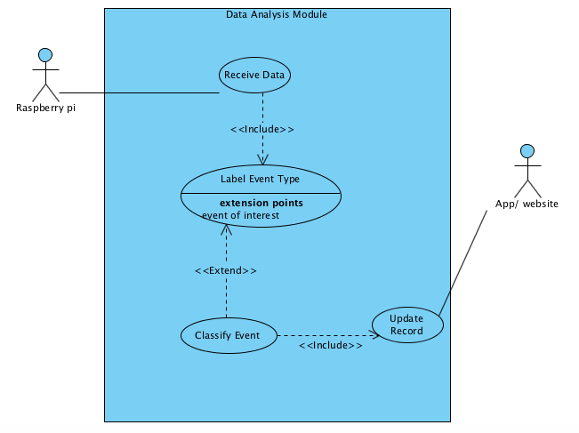

Figure 3.2 DAM Use Case Diagram

## Design constraints

Table 3.2 Technical design constraints

|  |  |  |
| --- | --- | --- |
|  | Name | Description |
| Hardware | Supply voltage/ Current/ Power | * The system need supplied voltage 5V. |
| Memory | * The system must have 500MB of memory. |
| Delay | * The transmitting delay of must be less 5 minutes. |
| software | Modifiability | * The system must be modifiable in case there is any change in recklessness measures or any update in used methods. |
| Scalability | * Data processing is near to where the data is being gathered, so not to cause over head in the server side and be able to handle larger number of users. |
| Availability | * The system is available 24/7 and ready for any driving trip. |
| Performance | * Segmentation is real-time process. |

Table 3.3 Practical design constraints

|  |  |
| --- | --- |
| Type | Description |
| Environmental | * The system must operate in extreme weather conditions up to 50 c |
| Manufacturability | Final product could be mass produced and components are available. |
| Sustainability/ maintainability | * The system must be able to automatically update in time and be up to date. * The system must be enclosed and protected from any external factors. |
| Security/ Ethical | * The system must respect the privacy of the user and secure personal data. |

## Design standards

Table 3.4 Design Standards

|  |  |
| --- | --- |
| Telecommunication Standards | Description |
| Networking Standard | * HTTP (Hypertext transfer protocol) * TCP |
| Wireless standards | * GPS (Global positioning system) * Wi-Fi (or IEEE 802.11) |

## Professional Code of Ethics

Table 3.5 Code of Ethics

|  |  |
| --- | --- |
| 1. IEEE Code | Description |
| To be honest and realistic in stating claims or estimates based on available data | Data Analysis Module classifies driver’s behavior based on the data collected, and recklessness metric is decided based on extensive studying of driver’s records. |
| To seek, accept, and offer honest criticism of technical work, to acknowledge and correct errors, and to credit properly the contributions of others; | Volunteers are to participate in data collection and testing the system, their opinion is valuable as it helps in defining reckless behavior. |
| To hold paramount the safety, health, and welfare of the public, to strive to comply with ethical design and sustainable development practices, and to disclose promptly factors that might endanger the public or the environment; | Driving experiments are authorized and take place in remote streets where there are no risks on people or public property. |
| To improve the understanding by individuals and society of the capabilities and societal implications of conventional and emerging technologies, including intelligent systems; | Some people may have concerns about putting an electronic device in their cars that tracks their driving trips and score their behavior. The benefits of such system are mentioned with stated evidence. |
| To avoid injuring others, their property, reputation, or employment by false or malicious action; | Drivers’ records are highly secured and recklessness classifications are not to be permanently attached with the derivers. |
| To assist colleagues and co-workers in their professional development and to support them in following this code of ethics. | Team members are to help each other in both aspects of the project (Hardware and software), and assist each other’s work to make sure the code of ethics is followed |

## Assumptions

1. Recklessness scale is not clearly demonstrated and may vary from one person to another. But we can generalize it as” any action that endangers anyone’s life inside or outside the car by any mean “.
2. Sensors used are capable of accurately collecting needed data to detect events of interest.
3. We will have access to a lot of data to achieve the expected accuracy.

# Solution design

## Overview

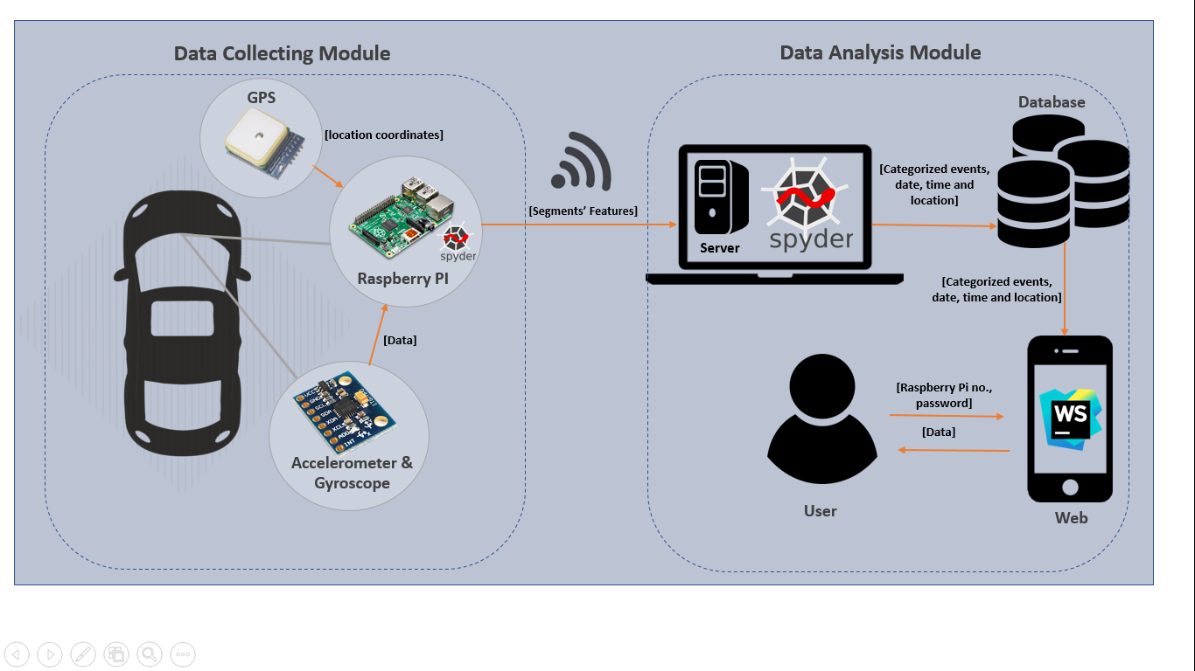

Figure 4.1 High-Level Architecture

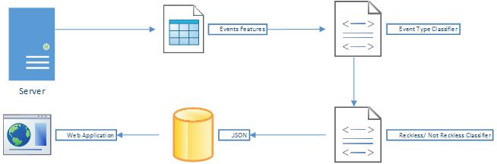

Figure 4.2 System Flow

The project will consist mainly of two systems working in series where the output of the first system is the input to the second. The first system is the Data Collecting module and the second is the Data Analysis module. The Data Collecting module integrates different hardware components such as Raspberry PI, accelerometers, gyroscopes, and GPS. This module collects data about the car movement. While the data is being collected, the Raspberry PI will be segmenting the data that is being received from the sensors based on an event detection algorithm of our design. Only the events, any change in the data received, are saved on the memory of the raspberry PI. The Raspberry PI then sends the segmented data to the Data Analysis module where the detection of the event type happens along with the classification of the event as reckless or safe. This system employs machine learning algorithms (Support Vector Machine, Random forest) and a neural network (Multilayer Perceptron) in order to detect the event type and classify it. The results of the analysis will be displayed to the user either through a website.

## Hardware/software used

Table 4.1 Software/ Hardware Used

|  |  |  |  |
| --- | --- | --- | --- |
| Software | Component | Description | Justification |
| Screen Clipping  Figure 4.3 spyder -The Scientific PYthon Development EnviRonment | This an open source cross-platform integrated development environment for scientific programming in the Python language. | This specific IDE is chosen because of the different tools it provides for signal processing such as NumPy, Matplotlib… etc.  It is used to segment the data received from the sensors based on the events detected. |
| Screen Clipping  Figure 4.4 MATLAB | An interactive high level language that uses object- oriented features and consider arrays as the basic element. This allows the user to solve computing problems involving matrices and vectors very easily. | MATLAB is used in the Data Analysis Module to identify events type and classify if they are reckless or not. |
|  | ../Screen%20Shot%202017-04-27%20at%201.16.36%20PM.png  Figure 4.5 WebStorm | A coding assistance for JavaScript and other languages that can be compiled to JavaScript, such as Node.js, HTML and CSS. Also, it assists Angular implementation and other frameworks. | WebStorm is used to build the web/ app for users to access driving records. |
|  | Figure 4.6 eclipse | An integrated development environment (IDE). It’s used for computer programming and most widely for java programming.  Contains a base workspace and an extensible plug-in system for customizing the environment. | Eclipse is used for building the server in our project since java eases the process of multithreading and can be easily made secure in the future. |
| Hardware | https://res.cloudinary.com/www-arduiely-com/image/upload/v1494277911/r5poemnjdafv1kybgmef.jpg  Figure 4.7 Triple Axis Gyroscope & Accelerometer Module | * This board is a PCB interface board with a 3-axis gyroscope and a 3-axis accelerometer, in addition to an onboard Digital Motion Processor. | It was chosen due to its:   * low power supplier is needed (3-5V) * low cost * high-performance requirements of smartphones, tablets * wearable sensor ability * Simple I2C interface   Availability in a local supplier in Qatar. |
| Figure 4.8 Raspberry Pi 3 Official Desktop Starter Kit (16Gb, White) | •  The Raspberry Pi 3 Model B builds upon the features of its predecessors with a new, faster processor on board to increase its speed. this Raspberry Uses wireless module technology and ARM Cortex processor. | It was chosen due to:  • Ability to handle heavy functions like segmentation process.  • Ability to communicate with other device over Wi-Fi and Bluetooth, this is needed in our project to send segmented data to the DAM.  • Low cost compared to other types of microcontroller |
| Image result for Waveshare NEO-7M-C (B) GPS Module  Figure 4.9 Waveshare NEO-7M-C (B) GPS Module | * This GPS Module provides location, heading, and speed data, it has NEO-7M-C on board, with high-gain active antenna, and it uses IPX interface, to connect active antenna. | It was chosen due to:   * Low cost compared to other GPS modules * Track the vehicle’s location. * Specify the locations corresponded to reckless events   low power supplier is needed (2.7-5V) |
|  | /var/folders/ss/ggytnq_54dv42rwszbsj548c0000gn/T/com.microsoft.Word/WebArchiveCopyPasteTempFiles/wF6gbLhKh0vsgAAAABJRU5ErkJggg==  Figure 4.10 D-Link AC1200 Wi-Fi Router | * This router has 802.11 a/g/n/ac wireless LAN, it has four 10/100 Fast Ethetnet LAN Ports, 10/100 Fast Ethernet WAN Port, it has 5dBi High Gain Dual Band Antennas and it has the feature of Dual Band Technology (2.4 GHz and 5 GHz) | It was chosen due to:   * It’s high-power signal and bigger coverage * It’s low cost and local availability * This is used to establish a network between the server and all registered Raspberry pi. |
|  | Car power Adapter | * Power indicator with LED * Input voltage: 12V-24V DC * Output voltage: 5V * Output current: 2.1Amp and 1Amp | It was chosen due to:   * Its features which satisfies the project needs, so it can be used to power the raspberry pi from the car |

## Hardware design

To design our system, it is first needed to collect data of the kinematics of the car. It’s needed to collect the acceleration of the car in all three axis and also the angular velocity and orientation in the z-axis. Moreover, information about the location of the car is also needed to be able to identify where certain events occurred. While the data is being collected, it should also be segmented to extract only data when events occur. The events that our project detects are right turn, left turn, reckless right turns, reckless left turns, speed bumps, reckless speed bumps and sudden brakes. Anything else is classified as no event. The segmentation that happens on the raspberry PI only brakes the data into segments based on the change of the samples. An example of how the segmentation works is shown in Figure 4.11 below. When an event occurs, a change can be noticed in the signal. An example of that is the data inside the red boxes in the figure. The segmentation code should be able to correctly segment such events regardless of their size so that they can be classified later.

Therefore, we first need an IMU to collect the kinematics data and a GPS to collect location data. For the IMU, we used the MPU6050 chip. Then for location coordinates, we used NEO-6M GPS Module. The functionality of each is described below.

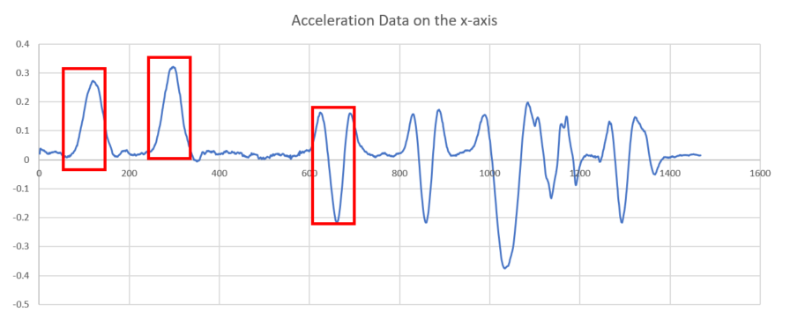

Figure 4.11 Example of Segmentation Output

### 

### Raspberry PI

Raspberry pi is a major hardware component in our design, it is needed to interface with Triple Axis Gyroscope & Accelerometer and NEO6MV2 GPS Module. The Raspberry Pi is credit-card-sized computer. It has a Quad-core 64-bit ARM Cortex A53 clocked at 1.2 GHz and a memory size of 8 GB. It also has 4 USB ports for connectivity with different devices and HDMI port for screen display. The power source is 5V via MicroUSB. Moreover, it has a built-in 802.11n Wireless LAN connectivity as well as built-in Bluetooth connectivity.

The Raspberry PI was our choice for the design due to many reasons. First, it’s affordable and available locally. Second, it has 512 MB of RAM, which allows us to run the needed scripts at the same time. This is needed since the raspberry PI collects data from the sensors and at the same time performs segmentation and feature extraction in parallel.

The segmentation script is run every five minutes of the collected. The process is as follows:

Each time the Raspberry PI is powered on it automatically opens a new file and starts reading data from MPU6050 and 6MV2 GPS for 5 min. Then, it opens another file to read more data and, at the same time, another algorithm takes place which is segmentation. It starts segmenting the ready file, and extracts features of each segment. All features are saved into a file to be sent latter to the server. Accordingly, while the raspberry pi is turned on this process is repeated every 5 minutes. A flowchart of this process is shown in Figure 4.12. After that, when the car becomes within the range of the router, a pushbutton that is connected to raspberry pi should be pressed. The file of all features is sent to the server. Therefore, only the features of the segments are sent and not the entire raw data.

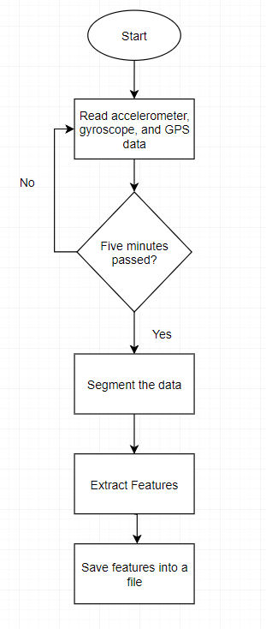

Figure 4.12 Flowchart of Process inside the Raspberry Pi

### MPU-6050 Triple Axis Gyroscope & Accelerometer

MPU6050 sensor module is an integrated 6-axis Motion tracking device, it contains a MEMS accelerometer and gyroscope, so it provides gyroscope readings in units of degrees per second (dps), and accelerometer readings in g unit. Any microcontroller can communicate with MPU6050 using I2C communication protocol.

MPU6050 provides acceleration in 3 axis x, y and z the direction of the three axis is shown in Figure 4.13. For example, moving the sensor forward will result in increasing y values, moving it to the right will increase value of x-axis, Table 4.2 shows details of all movements in 3 axes.

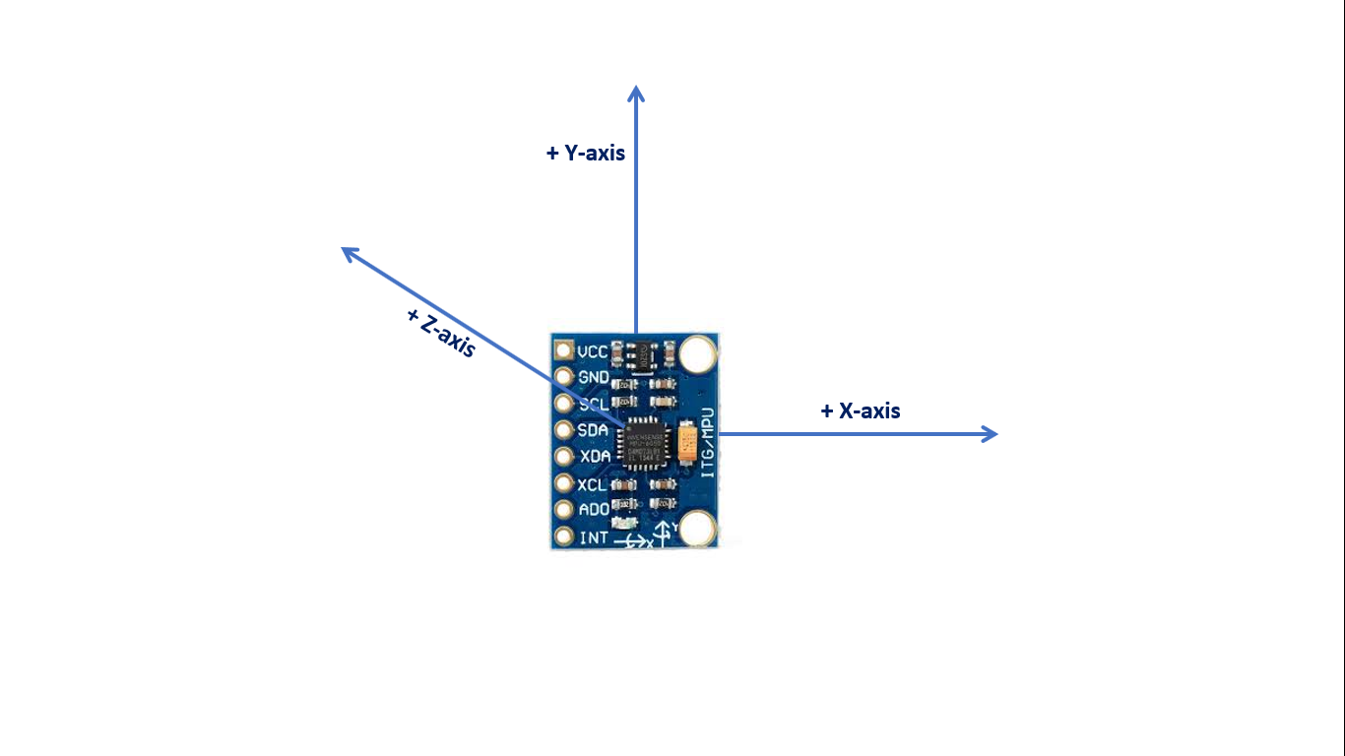

Figure 4.13 axis direction of accelerometer

Table 4.2 movements and the changes in each axis

|  |  |  |  |  |  |  |
| --- | --- | --- | --- | --- | --- | --- |
| Movement | Change in x-axis | | Change in y-axis | | Change in z-axis | |
|  | Positive | Negative | Positive | Negative | Positive | Negative |
| Upward |  |  |  |  | ✓ |  |
| Downward |  |  |  |  |  | ✓ |
| Right | ✓ |  |  |  |  |  |
| Left |  | ✓ |  |  |  |  |
| Forward |  |  | ✓ |  |  |  |
| Backward |  |  |  | ✓ |  |  |

MPU-6050 was our choice due to its low cost and local availability in Qatar. Additionally, it provides both acceleration and gyroscope readings at the same time, so only one module is needed instead of 2 separate modules for the 2 different readings (acceleration and gyroscope data), so in our design MPU-6050 is interfaced with the raspberry pi and it records acceleration, orientation and angular velocity of a car in all three axis (X, Y and Z) every 0.1 second during the whole duration of each trip. Raspberry pi can be easily interfaced with MPU 6050 by setting the electrical connections correctly and writing some commands on raspberry pi terminal:

**Electrical connection:**

The 4 upper pins of MPU 6050 are connected to raspberry pi as shown in Table 4.3, then Figure 4.14 shows a wiring diagram of raspberry pi and MPU6050 based connections provide in the table.

Table 4.3 Electrical connections between raspberry pi and MPU6050

|  |  |
| --- | --- |
| Raspberry pi | MPU6050 |
| Pin 1 (3.3V) | VCC |
| Pin 3 (SDA) | SDA |
| Pin 5 (SCL) | SCL |
| Pin 6 (GND) | GND |

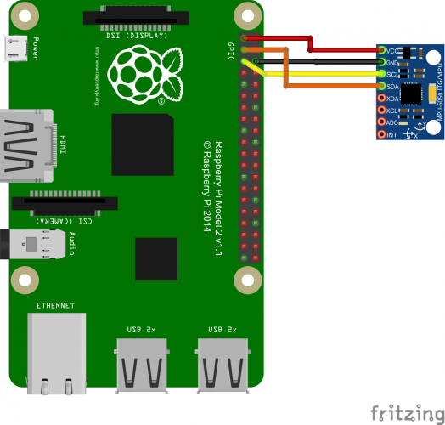

Figure 4.14 wiring diagram of raspberry pi and MPU6050

* + - Commands and setting of raspberry pi:

1. I2C protocol on Raspberry Pi needs to be turned on from raspberry pi configurations.
2. Python-smbus package needs to be installed by using this command

*sudo apt-get install gpsd gpsd-clients*

1. Then a python code need to be written to read data from MPU6050 during a trip.

### NEO5MV2 GPS Module

The NEO-6 module is a GPS module that records the data related to tracking position in real time. Its compact architecture and power, memory options and its high level of integration capability with the flexible connectivity options makes NEO-6 modules the best choice for our design. It comes with a Ceramic antenna, LED signal indicator.

NEO6MV2 GPS Module is needed in our design to provide all possible location coordinates (latitude and longitude) of the car during a trip to make the system able to identify where certain events occurred, this can be done by interfacing it with the raspberry pi using some electrical connections, downloading some packages and writing python code, each is explained separately in the below:

Electrical connections

The NEO6MV2 GPS module comes with 4 connections: RX, TX, VCC and GND, which is quite easy to incorporate with using the UART connector on the Raspberry PI. To connect NEO6MV2 GPS to raspberry pi electrically pins should be connected as mentioned in Table 4.4. Then Figure 4.15. Shows a wiring diagram of raspberry pi and NEO6MV2 GPS module based on connection mentioned in the table.

Table 4.4 Electrical connections between raspberry pi and NEO6MV2

|  |  |
| --- | --- |
| Raspberry pi | NEO6MV2 GPS module |
| Pin 1 (3.3V) | VCC |
| Pin 10 (GPIO15) | TX |
| Pin 8 (GPIO14) | RX |
| Pin 6 (GND) | GND |

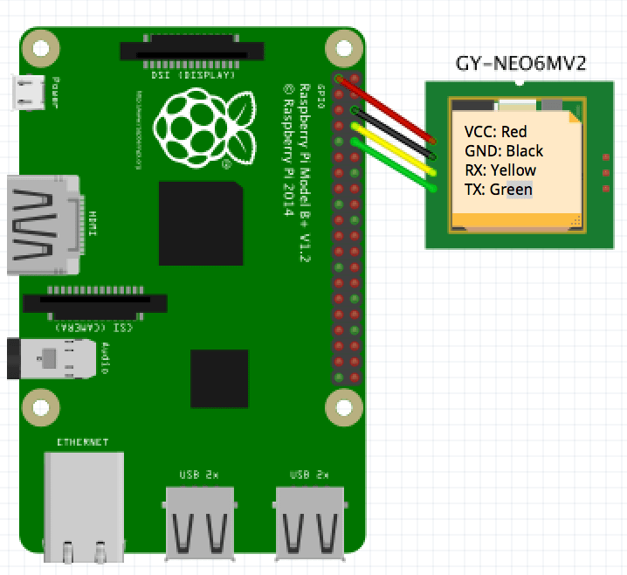

Figure 4.15 wiring diagram of raspberry pi and NEO6MV2

1. Commands to setup raspberry pi to interface it with NEO6MV2 GPS
2. Install gpsd-clients Package in rapberry pi by typing this command in terminal

*sudo apt-get install gpsd gpsd-clients*

1. Execute gpsd (The GPS daemon) pi by typing this command in terminal:

*sudo gpsd /dev/ttyAMA0 -F /var/run/gpsd.sock*

1. Read data from GPS by typing this command in terminal:

*cgps -s*

*As a result* of these commands, the terminal shows a window similar to the one in Figure 4.16, where time, latitude, longitude and other minor information are available.

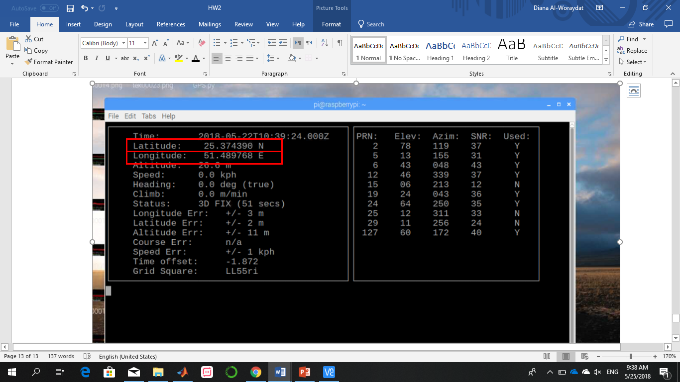

Figure 4.16 output of “cgps -s” command

1. The last step is writing a python code to read data from NEO6MV2 GPS module, extract latitude and longitude values and save it to a file in addition to other value like acceleration and gyroscope values.

### Network

Regarding the network communication, we established the network using D-Link AC1200 Wi-Fi Router, which has the following features:

* Wireless speed reaches up to 300Mbps
* Four 5 dBi antennas for high-power signal and bigger coverage
* Preset security with advanced WPATM/WPA2 encryption and easy, secure connection using Wi-Fi Protected Setup
* Dual Band Technology (2.4 GHz and 5 GHz) for flexible wireless with reduced interference

Two main components are responsible about this connection, a client and a server, this server is established on a computer machine and the client on the Raspberry Pi. In addition, the built-in wireless connectivity in the Raspberry Pi allows it to communicate with the server without the need of an external Wi-Fi module. They are both connected to the network through 802.11 WLAN. This network plays an important role in the project, when a trip is over and the car came back to the main station where the router is, the driver needs to press a pushbutton that is connected to the Raspberry Pi to start the connection if the connection is established, the file where all features are stored in, will be sent to the sever to classify all segments into no event, event type (right turn, left turn, speed bump, sudden brake) and classified event (safe and reckless).

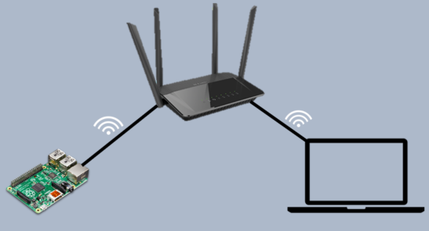

Figure 4.17 Network Diagram

## Software design

### Classification

A learning problem considers a set of data examples then tries to predict a class for unknown data. In the case of supervised learning, data comes with extra attribute that the algorithm predicts. In this project the problem is a classification problem. Collected data belongs to one class and our goal is to train classifiers with already labeled data how to predict the class of unlabeled data. In the process of designing this project. A number of Supervised Machine Learning classification algorithms and a Neural Network were trained and tested on collected data of various driving events. Their output was compared to the original labels and the accuracy of their performance was measured as given in Table 4.5 and 4.6. Choosing the most convenient classifiers to be implemented in this system was based on a selected criterion that ensures high accuracy of event classification, since the system is to be used in assisting drivers and assigned labels to their driving behavior. In addition to adopt a classifier that is consistent with all design constrain noted earlier such as memory space and execution speed.

Table 4.5 Machine learning Algorithms Accuracies

| Algorithm | Type of Event | | | | |
| --- | --- | --- | --- | --- | --- |
|  | Right Turn | Left Turn | Speed Bump | Sudden Brake |
| Dummy Classifier | 45% | 51% | 37% | 61% |
| Random Forest | 94% | 93% | 93% | 98% |
| Nearest Neighbors | 90% | 92% | 90% | 98% |
| Linear Support vector machine | 90% | 92% | 97% | 95% |

Table 4.6 Multilayer perceptron Event Accuracies

|  |  |  |  |  |
| --- | --- | --- | --- | --- |
|  | Right Turn | Left Turn | Speed Bump | Sudden Brake |
| Multi-Layer Perceptron | 90% | 93% | 93% | 93% |

The three classifiers used in this project are Support Vector Machine, Multilayer Perceptron, and Random forest as shown in Table 4.5 and Table 4.6. These 3 algorithms outperformed other tested algorithms such as nearest neighbors, and dummy classifier in classification. The other classifiers were eliminated either for their low accuracies or for contradicting with one or more of the design constraint, as in the case of Nearest Neighbors which is described as a lazy classifier. KNN searches through all the data examples to find the nearest example instead of learning a discriminative function, which in the case of having a large dataset will result in an undesired delay.

Binary Classification is adopted as a design choice for the classifiers employed to determine the type of event. The same applies for safe/ reckless classifiers. The aforementioned decision was based on the comparison between the output quality of experiments performed using Multi-Class Classification and Binary Classification as shown in Table 4.7. Binary classifiers targets each individual class separately which produces specialized classifier for each event type. While Multi-class tends to minimize the error for all classes as a whole. Moreover; some selected classifiers in this project are binary classifiers by nature such as SVM, which should be adapted first to solve multi-class problems. Hence, using binary classification result in higher accuracies and gives more alternatives.

Table 4.7 Multiclass Vs Binary Classification accuracies

|  |  |  |
| --- | --- | --- |
|  | Multi-Class Left Turn | Binary Class Left Turn |
| Linear Support vector machine | 80% | 97% |
| Multi-Layer Perceptron | 74% | 97% |
| Random Forest | 85% | 93% |

For each type of events, 3 classifiers are designed to output the event type. These 3 outputs will be inserted into a voting mechanism to get 1 output based on the majority vote. According to that output, the event's features are passed to another 3 classifiers designed for that specific event type to classify the event as reckless or safe as can be viewed in Figure 4.18.



Figure 4.18 Classification layers

In order to calculate classifiers performance quality, measures such as accuracy, precision, and recall are calculated. A confusion matrix is constructed to show the actual values along with the predicted outcomes as in Table 4.8. Then the three measures are taken into consideration:

Accuracy: $=\frac{TP+TN }{TP+TN+FP+FN}$

Precision: $=\frac{TP }{TP+FP}$

Recall: $=\frac{TP }{TP+FN}$

 Precision is the number of correctly predicted positive examples out of all examples predicted as positive. Where TP are the true examples that where predicted by the classifier, TN are true examples that were not predicted, FP the false examples that were predicated as positive while they are not, and FN the false examples that where predicted as negative. Recall is the number of correctly predicted positive examples out of all examples that are in fact positive.

Table 4.8 Confusion Matrix

|  |  |
| --- | --- |
| Predicted Label | |
| Positive | Negative |
| Actual Label | True | TP | TN |
| False | FP | FN |

# Implementation

## Hardware Implementation

The hardware implementation consists of the implementation of the Data Collecting Module (DCM). The Raspberry Pi is interfaced with both the IMU and the GPS module. The IMU (MPU 6050) uses I2C protocol for communication and the GPS uses serial protocol. The wiring diagram is shown in Figure 5.1.

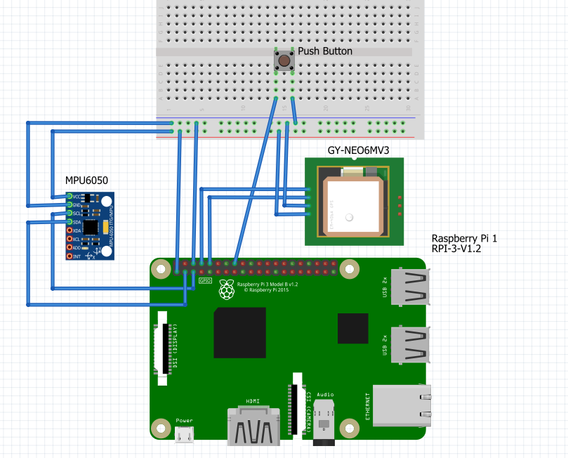

Figure 5.1 Wiring Diagram

The Raspberry Pi gets its power from the car battery. Since the car battery is 12V and the needed power supply is 5V, a 12V-5V adapter was used. A trip starts whenever the Raspberry Pi is turned on, with the start of the car, and ends when the Raspberry Pi is turned off, i.e. when the car is turned off. During the trip, the Raspberry Pi reads the sensors’ data every 0.1 seconds. Then, after 5 minutes, the data collected is segmented and their features are extracted and saved to a file. For every trip, there’s a different features file.

When a trip is over, and the driver is back to the base unit and in the range of the network, he must press a button on the module for all saved files of trip features to be sent to the server for classification. The overview of the DCM is shown in the figure below and each part is explained in detail in the following sections.

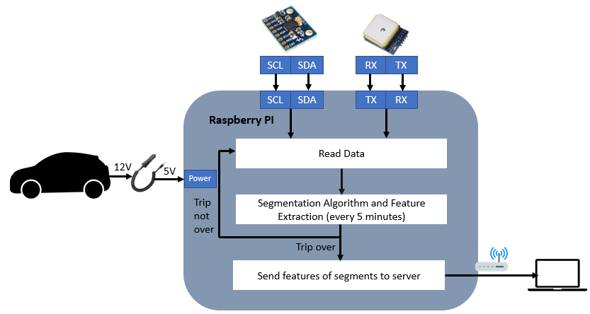

Figure 5.2 Overview of DCM Functionality

### Data Reading

 Reading data is the most important step of this project, in order to classify the driving behavior into reckless or not multiple driving events of the driver should be classified as reckless events. To do this multiple reading are necessary these reading are:

* x-axis acceleration
* y-axis acceleration
* z-axis acceleration
* x-axis gyroscope value
* y-axis gyroscope value
* z-axis gyroscope value
* GPS coordinates (latitude and longitude)
* Date
* Time

3 axes acceleration can be read from MPU6050 using a python code that read data during a driving trip, x y and z axis changes based on the direction of the car movements (this was mentioned in Table 4.2).

Table 5.1 shows all types of driving event that we tries to read and record, their description and graph plot of a trip with rectangle that show the specified event in theta row :

Table 5.1 Theory Vs Time series Events

|  |  |  |
| --- | --- | --- |
| Events | Theory | Triple Axis Accelerometer and Gyroscope |
| Right Turn | When the driver turns right, values on x-axis increase then decrease forming a peak on positive x-axis.  Rectangles in next graph shows x signal (red) of the right turns during a normal trip |  |
| Left Turn | When the driver turns left values on x-axis decrease then decrease forming a peak on negative x-axis  Rectangles in next graph shows x signal (red) of the right turns during a no rmal trip |  |
| Speed Bump | As the car moves over a speed bump values on z-axis increase then decrease forming a peak on +z axis  Rectangles in next graph shows z-signal (blue) of the speed bump during a normal trip |  |
| Sudden Brake | When the driver suddenly brake values on y-axis decrease suddenly forming a peak on negative y-axis  Rectangles in next graph shows y signal (green) of the sudden brake during a normal trip |  |
| No Event | When car is at rest, like stopping on a traffic, signal all values of accelerometer remain constant  x-signal (red)  y-signal (green)  z-signal (blue) |  |

Right turn, left turn and speed bump event mentioned in the table are normal event that’s why the peaks are smooth. However, reckless turns and speed bump forms sharper peaks that describes the sudden change.

### Segmentation Algorithm

For segmenting, we used the Bottom- Up algorithm. The Bottom-Up is an algorithm where the data is segmented starting from the finest possible approximation of the time series. First, the data is divided into a number of very small segments of equal lengths. Putting n as the length of the time series, n/2 segments are used for the approximation. Next, the segments are merged after the calculating the merging cost of each pair of adjacent segments. The pairs with the lowest merging cost are merged together until some stopping criteria is met [ 17] In other words, the pairs that when merged because the smallest increase in error are merged into a bigger segment. The stopping criteria could be when the approximation error is greater than threshold, or a pre-specified number of segments [17]. In our case, it’s the latter. This process also includes bookkeeping because at first the cost of merging segment i and segment i+1 is calculated and then the cost of merging segment i-1 with the newer larger adjacent segment is recalculated. The pseudocode of the algorithm and the flowchart are shown in the figures below in Figure 5.3 and Figure 5.4.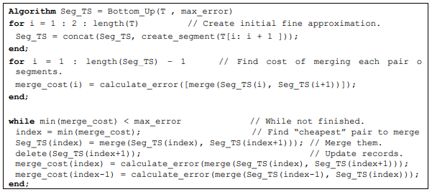

Figure 5.3 Pseudocode of Segmentation Algorithm

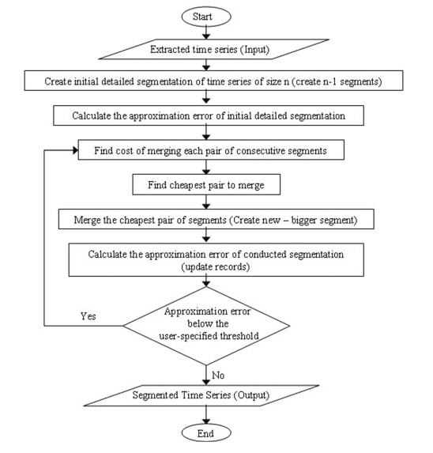

Figure 5.4 Flowchart of Segmentation Algorithm

#### Converting the code to python and results comparison:

Part of the segmentation code was already available in matlab from [17]. However, because the segmentation process occurs on the raspberry pi, the matlab code had to be ported to python. The conversion was manually done so to understand the functionality of the code better and to also only translate the parts that we need. The results of both the matlab code and the python code differ slightly because each use built in polynomial fit function and other math functions. These functions have some small differences when implemented in different programming functions. However, the segments were important events occur are well identified.

Comparing the resulted segments in matlab Figure 5.7 and 5.8, and in python Figure 5.5 and 5.6.of the same file, we get the following results. Certain events on the x-axis are segmented after being smoothed out for illustration purposes.

The first column of the result is lx, which is the index in the original data where the event starts, and the second column is the index in the original data where the event ends.

We can see the main events that are occurring at the higher peaks are segmented in both the python code and the matlab code. An example of an event is the segment that starts from sample 363 to sample 466 in the python code, which is the same segment that starts from sample 365 to sample 468 in the matlab code. Both segments are marked with a green box in the figures below.

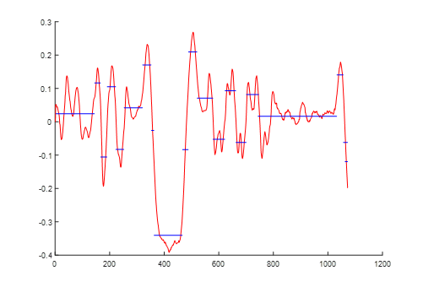

Figure 5.5 Segmentation Results of python code

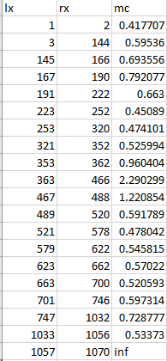

Figure 5.6 Segmentation Results of python code

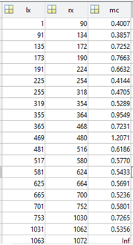

Figure 5.7 Segmentation Results of matlab code

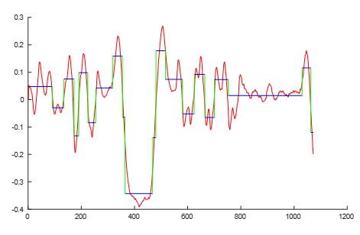

Figure 5.8 Segmentation Results of matlab code

### Feature Extraction

After each segment is generated, certain features are calculated for it. These features are the minimum, maximum, mean, standard deviation and variance. These features are saved into a file and the raw data of the segment are discarded in order to save memory space on the Raspberry Pi. The purpose of calculating these features is to feed them into different classifiers on the server side to determine both the type of event and whether or not it was reckless. We preferred feeding the features rather than the whole time-series data for several reasons. First, the classifiers that could be used with the features are a lot more than those that use time series data. Moreover, the segment sizes are not constant; that is because not all events take the same amount of time to occur. This will cause a problem since most classifiers need a fixed size segment as an input. Although padding can be a solution, it will result in altering the original data even slightly, which will later affect the accuracies of classification. An example of the features extracted is shown in the table below.

Table 5.2 Events Feature

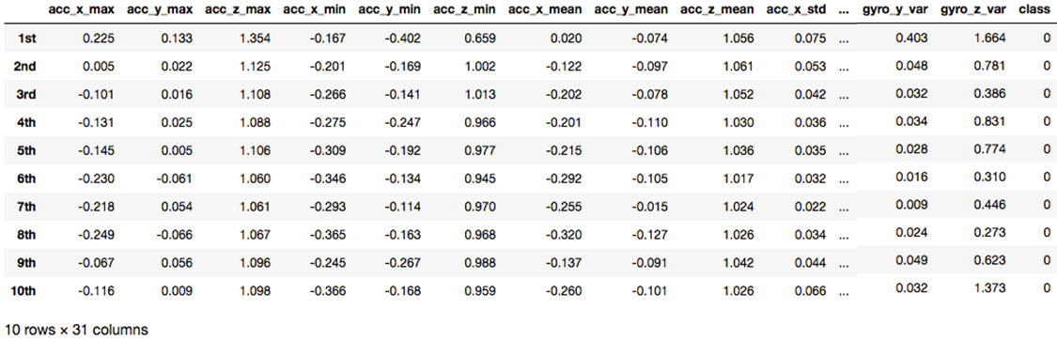

### Communication Protocol

A communication protocol was needed between both modules, the DCM and the DAM. A TCP server was implemented on the software side (DAM) that is responsible of receiving the features data at the end of each trip. The raspberry PI acts as the client that collects the pending data files that are yet to be sent and sends them. To prevent overhead at the server side and possibility of files not transmitted, the client merges all the pending files into one new file, deletes the pending files, and sends the new bigger file to the server. Once an acknowledgment is received from the server, the new file is also deleted. This way, no unneeded files are left on the raspberry PI and memory space is saved.

The communication protocol is illustrated in the figures below. The server is implemented using Java because both multi-threading and secure sockets could be easily implemented on it in the future. The client, on the other hand, is implemented using Python since it’s on the raspberry PI.

The communication is initiated from the client side. When the button is pressed, the client searches for all the pending files, merges them, and send a “Ready” message to the server. If the client receives an “OK” reply from the server, it sends its ID and Password to the server for authentication. The server authenticates the ID and password and sends an “Approve” message to the client if it succeeds and a “Terminate” message if it fails. When the client receives the “Approve” message, it sends the file name and the file size to prepare for the file transmission and so that the server knows when the file transmission will end. After that, the file is transmitted in byte stream to the server side, the server sends an acknowledgment message and the connection is terminated.

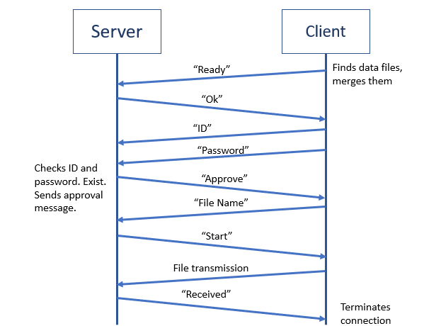

Figure 5.9 Successful Authentication

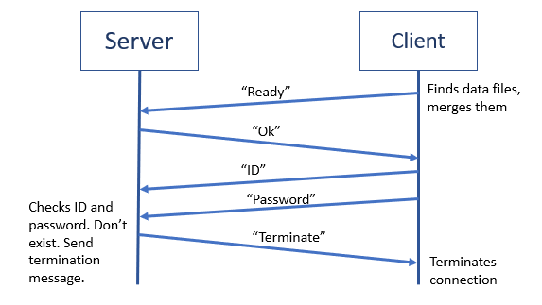

Figure 5.10 Failed Authentication

## 

## Software Implementation

### Classification

In this subsection, the details of the implementation of the Machine learning classifiers used are to be discussed, along with the outputs and their accuracies.

After feature extraction process mentioned in section 5.1.3. Figure 5.11 shows 10 examples from a saved dataset with 290 distinctive driving events represented in rows and their 30 features distributed in columns. This dataset is to be used in classifiers training and testing process.



Figure 5.11 features of 10 driving examples

The primary step in classifiers training and testing process is splitting the dataset. 70% and 30% for training and testing respectively. In our dataset, splitting the data resulted in two sets of different sizes. The first set is of size 203 examples, and the other set is of 87 example as shown in Table 5.3. X is data frames that contain events features, while Y contain the labels/ classes of these events. The first set is used in training classifiers, the second is used for the model to predict labels.

Table 5.3 splitting Dataset results

|  |  |  |  |
| --- | --- | --- | --- |
| X\_training size | Y\_training size | X testing size | y testing size |
| (203, 30) | (203,) | (87, 30) | (87,) |

After splitting the dataset, an instance of each classifier is created to be used in fitting and predicting. In this part of the report, the implementation the training process of Multilayer perceptron for left turns demonstrated. See Appendix[] for the full implementation.

$$mlp=MLPClassifier()$$

The set of training events along with their classes are fit into the classifiers. Contrarily, testing set is passed to the classifier for it to predict the event class.

$$\# fit the model for the trainig data$$

$mlp.fit(x-train, y-trai$*n)*

$$\#predict the labels of the test data$$

$$y-pred=mlp.predict(x-test)$$

In order to calculate how well the classifier is in predicting the classes. The outputs of prediction is compared with the actual labels and the classification accuracy is calculated. The following table shows accuracy, precision, and recall for multilayer perceptron used to detect left turns out of all other events.

Table 5.4 SVM Left Turns Performance

|  |  |
| --- | --- |
| Precision | Recall |
| 0 | 0.95 | 0.93 |
| 1 | 0.87 | 0.90 |
| Accuracy | 0.919 |

Table 5.5 RF Left Turns Performance

|  |  |
| --- | --- |
| Precision | Recall |
| 0 | 0.93 | 0.97 |
| 1 | 0.93 | 0.86 |
| Accuracy | 0.931 |

Table 5.6 MLP Left Turns performance

|  |  |
| --- | --- |
| Precision | Recall |
| 0 | 0.95 | 0.98 |
| 1 | 0.96 | 0.93 |
| Accuracy | 0.954 |

### Website

One main objective of this project is to visualize the results of performed classification. Webstorm is the tool used to implement this part of the project, it is a smart tool cross-platform IDE primarily for web, JavaScript, and TypeScript development.

A website is implemented using Webstorm to be the interface used by drivers to access their trips history and events summary. This provides users with an assessment of their driving behavior. Figure 5.12 shows the home page of the “Recklessness Detector” website.

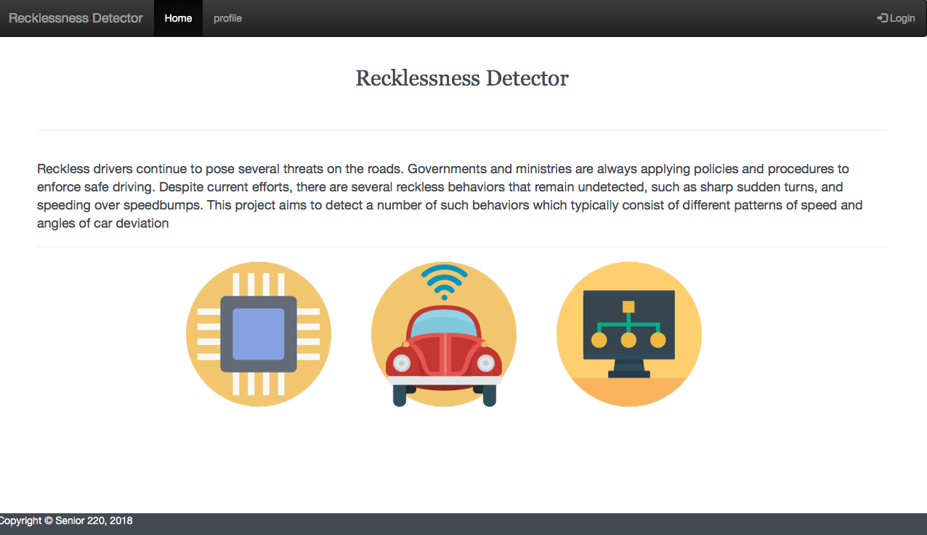

Figure 5.12 Home Page

The user logs into the system with a special Raspberry Pi ID and a password assigned when the unit is purchased as shown in Figure 5.13.

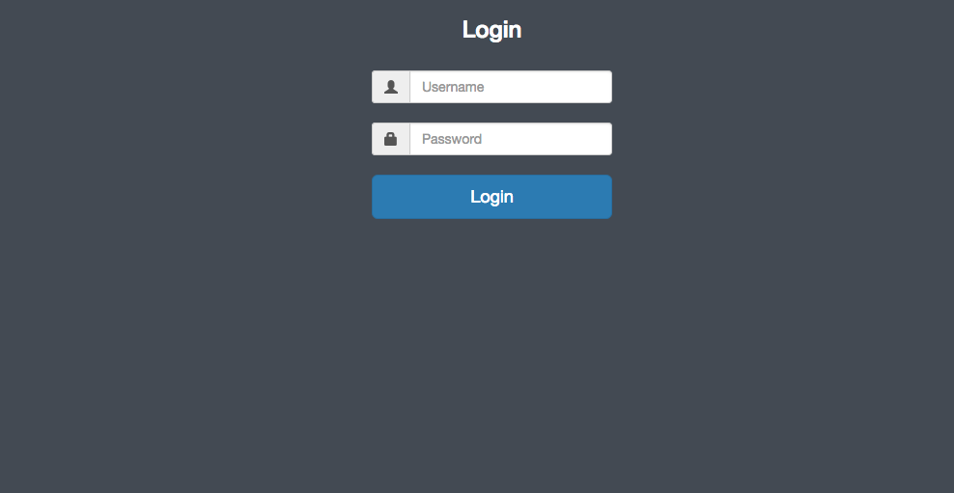

Figure 5.13 login page

Then users can go to "profile" page to get a list of recorded events that are automatically updated whenever a driving trip ends. Figure 5.14 shows and empty “profile “page for a newly used Raspberry pi with zero recorded events.

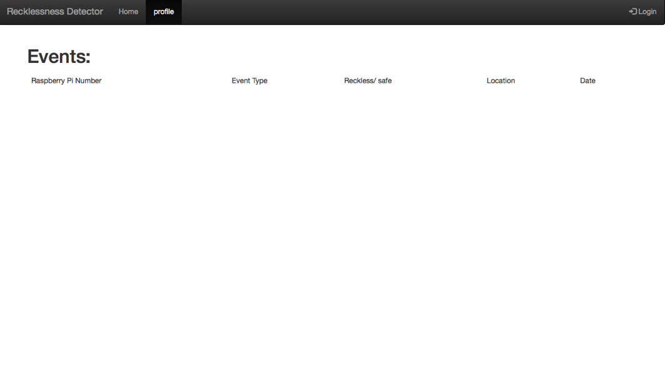

Figure 5.14 events page

Figure 5.15 shows the output of the classification for a trip saved and sent from the raspberry pi to be classified and for the results to be rendered into the webpage. The same output can be seen in the webpage along with the raspberry pi id, the event type, reckless or safe label, date of event, and the location linked from google maps as can be seen in Figure 5.16 and Figure 5.17.

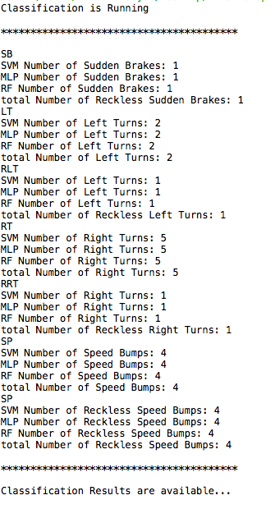

Figure 5.15 classification results

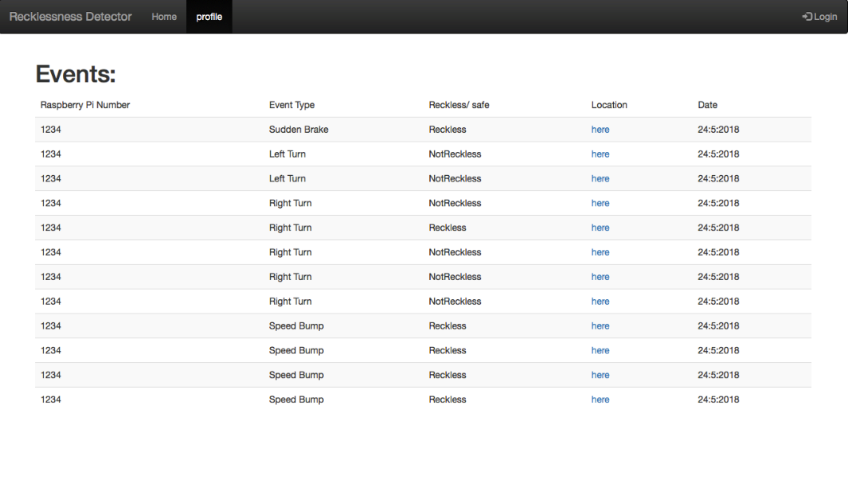

Figure 5.16 events page

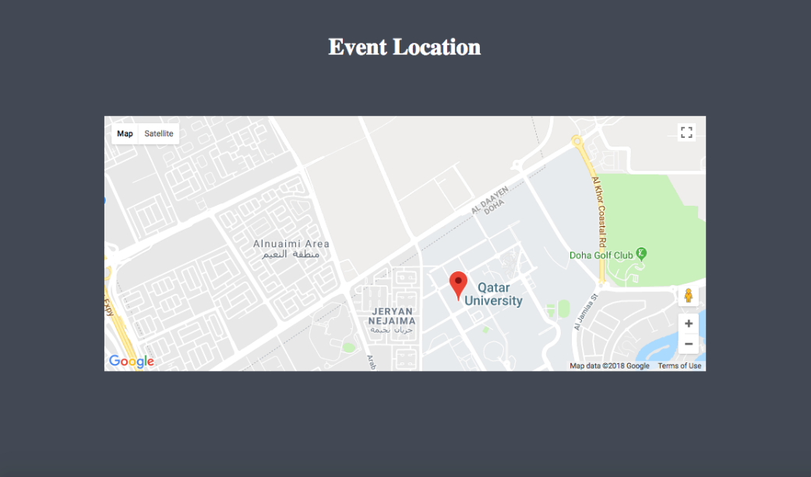

Figure 5.17 google maps to show the location

# 

# Testing

### Triple Axis Accelerometer and Gyroscope:

In order to test the capability and performance of the Triple Axis Accelerometer and Gyroscope in capturing the needed driving events; multiple experiments have been done.

While the sensors were collecting data, we manually recorded the type of event, date, time and either safe or reckless whenever a driving event occurred.

The following table illustrates examples of several recorded events and its reflection on the collected data.

1. Right Turn:

Table 6.1 shows 2 reckless right turns and 3 safe right turns with their date, time and classification (safe or reckless event ), then in Figure 6.1 Reckless right turn 1 is plotted. It is clear from this figure that the plotted right turn matches the concept of right turn signals where peak is formed on positive x-axis.

Table 6.1 Right turn events

|  |  |  |  |
| --- | --- | --- | --- |
| Type of Event | Date | Time | Reckless/safe |
| Right Turn 1 | 15-05-2018 | 18:49 | Reckless |
| Right Turn 2 | 15-05-2018 | 18:51 | Reckless |
| Right Turn 3 | 22-04-2018 | 12:58 | Safe |
| Right Turn 4 | 22-04-2018 | 12:59 | safe |
| Right Turn 5 | 22-04-2018 | 13:01 | safe |

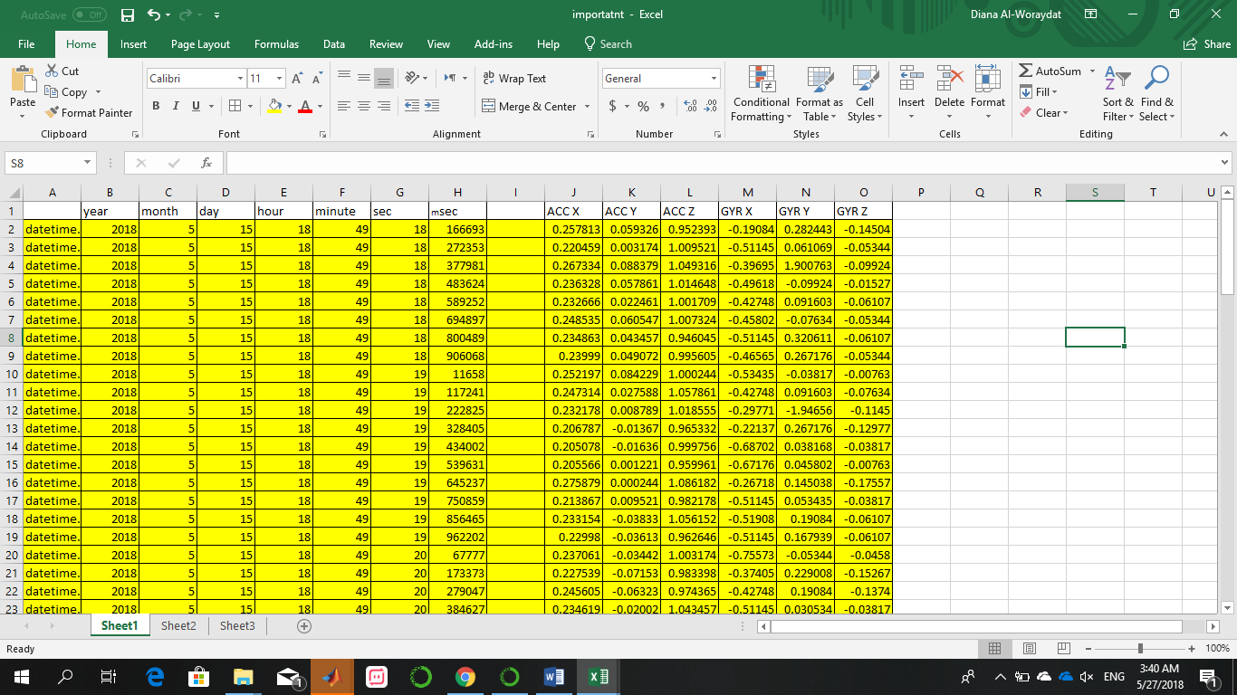

Figure 6.1 Accelerometer and Gyroscope data of Reckless Right Turn 1

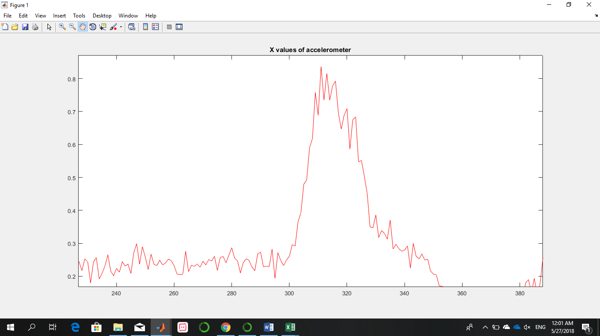

Figure 6.2 x-axis Accelerometer data of Reckless Right Turn 1

1. Left Turn:

Table 6.2 shows 2 safe left turns and 3 reckless left turns with their date, time and classification. Figure 6.3 shows data of safe left turn 1 as a sample, then in Figure 6.4. Safe left turn 1 is plotted. It is clear from this figure that the plotted left turn matches with the concept of left turn signals where smooth peak is formed on negative x-axis.

Table 6.2 Left Turn

|  |  |  |  |
| --- | --- | --- | --- |
| Type of Event | Date | Time | Reckless/safe |
| Left Turn 1 | 22-04-2018 | 13:00 | safe |
| Left Turn 2 | 2-05-2018 | 21:41 | safe |
| Left Turn 3 | 15-05-2018 | 18:24 | Reckless |
| Left Turn 4 | 15-05-2018 | 18:39 | Reckless |
| Left Turn 5 | 15-05-2018 | 18:42 | Reckless |

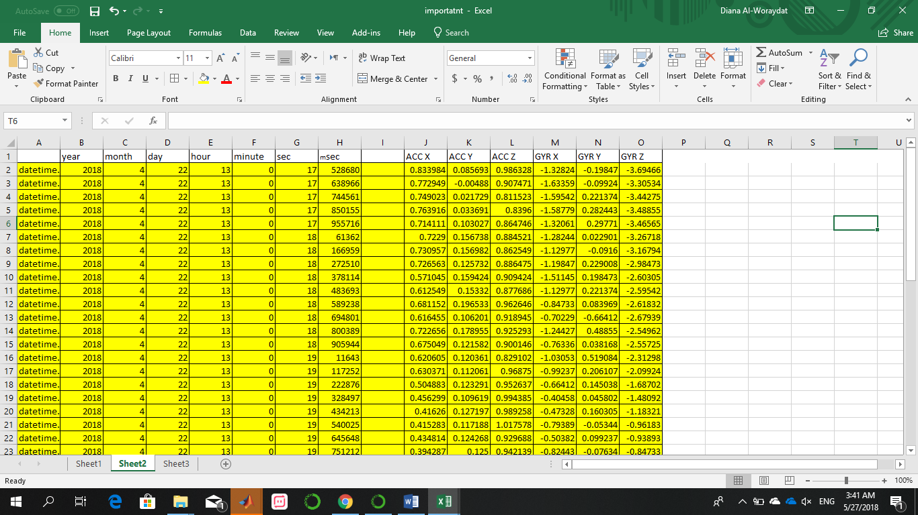

Figure 6.3 Accelerometer and Gyroscope data of Left Turn 1

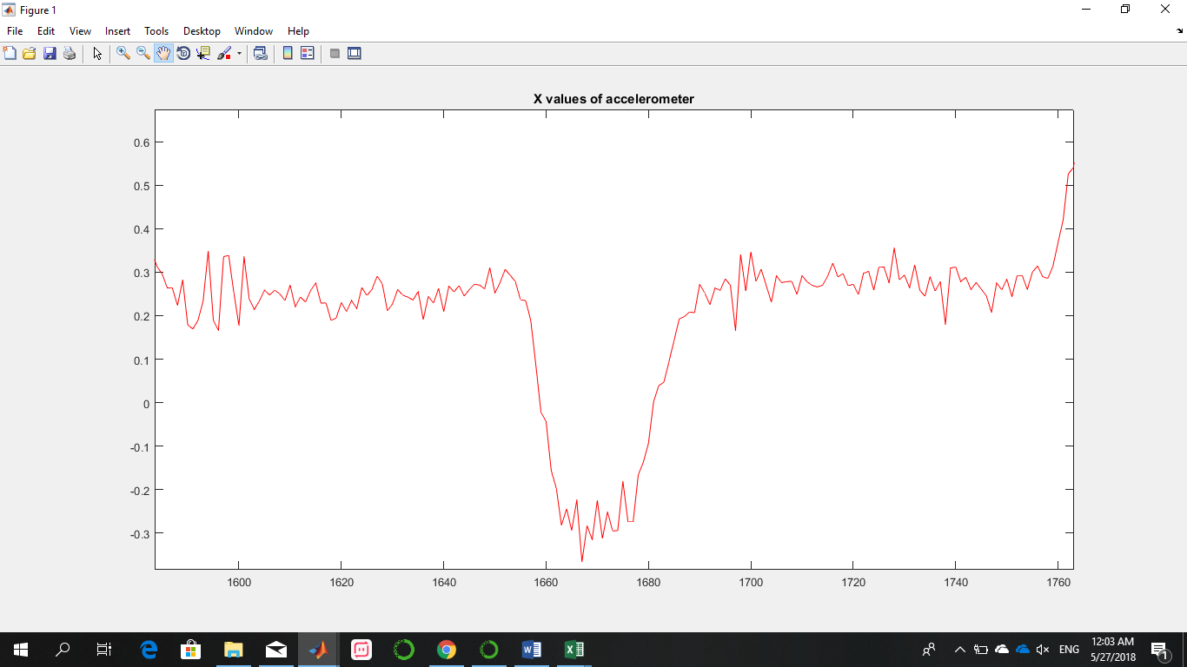

Figure 6.4 x-axis Accelerometer signal of Left Turn 1

1. Sudden Brake:

Table 6.3 shows 5 Reckless Brakes with their date, time and classification. Figure 6.5 shows data of Reckless Brake 1 as a sample, then in Figure 6.5. Reckless brake is plotted. It is clear from this figure that the reckless brake matches with the concept of reckless brake signals where a sharp peak is formed on negative y-axis.

Table 6.3 Sudden Brake

|  |  |  |  |
| --- | --- | --- | --- |
| Type of Event | Date | Time | Reckless/safe |
| Sudden Brake 1 | 15-02-2018 | 21:48 | Reckless |
| Sudden Brake 2 | 15-02-2018 | 21:49 | Reckless |
| Sudden Brake 3 | 15-02-2018 | 21:49 | Reckless |
| Sudden Brake 4 | 15-02-2018 | 18:50 | Reckless |
| Sudden Brake 5 | 15-02-2018 | 18:52 | Reckless |

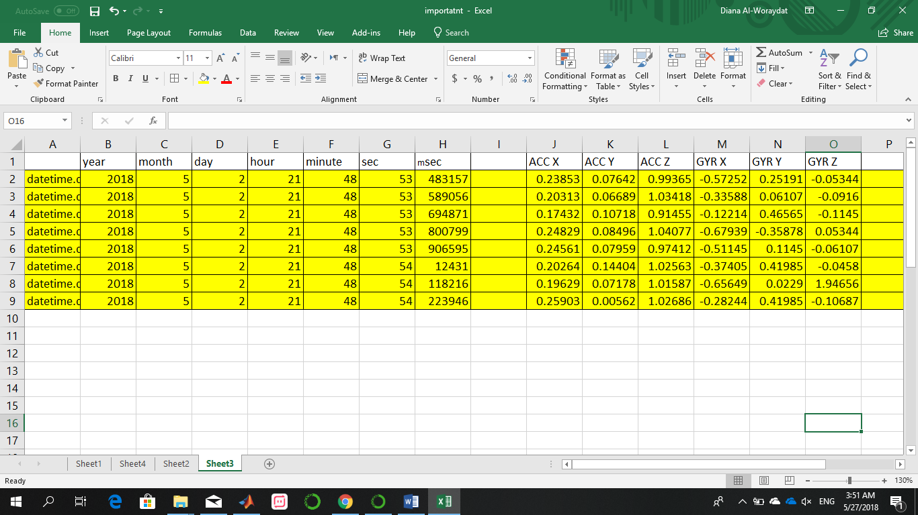

Figure 6.5 Accelerometer and Gyroscope data of Reckless Sudden brake 1

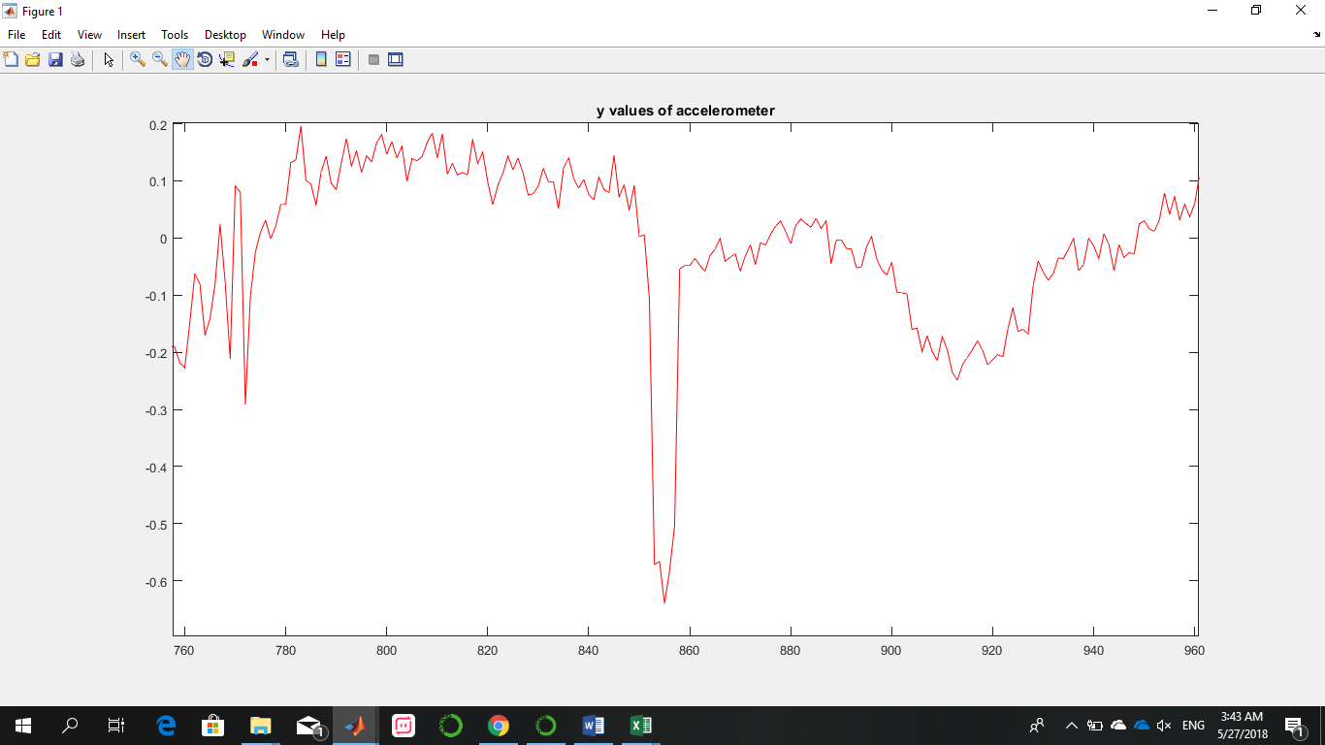

Figure 6.6 Y-axis Accelerometer signal for Sudden Brake 1

1. Speed Bump:

Table 6.4 shows 5 speed bumps with their date, time and classification. Figure 6.7 shows data of reckless speed bump 1 as a sample, then in Figure 6.8 reckless speed bump is plotted. It is clear from this figure that this speed bumps matches with the concept of reckless speed bumps signals where sudden increase is formed on positive and negative z-axis.

Table 6.4 speed bumps

|  |  |  |  |
| --- | --- | --- | --- |
| Type of Event | Date | Time | Reckless/safe |
| Speed Bump 1 | 15-05-2018 | 18:29 | Reckless |
| Speed Bump 2 | 15-05-2018 | 18:30 | Reckless |
| Speed Bump 3 | 15-05-2018 | 18:31 | Reckless |
| Speed Bump 4 | 15-05-2018 | 18:32 | safe |
| Speed Bump 5 | 15-05-2018 | 18:33 | safe |

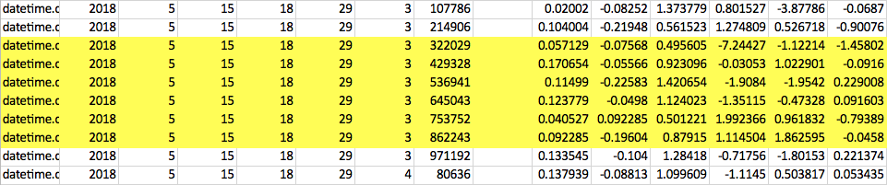

Figure 6.7 Accelerometer and Gyroscope data for Reckless speed Bump 1

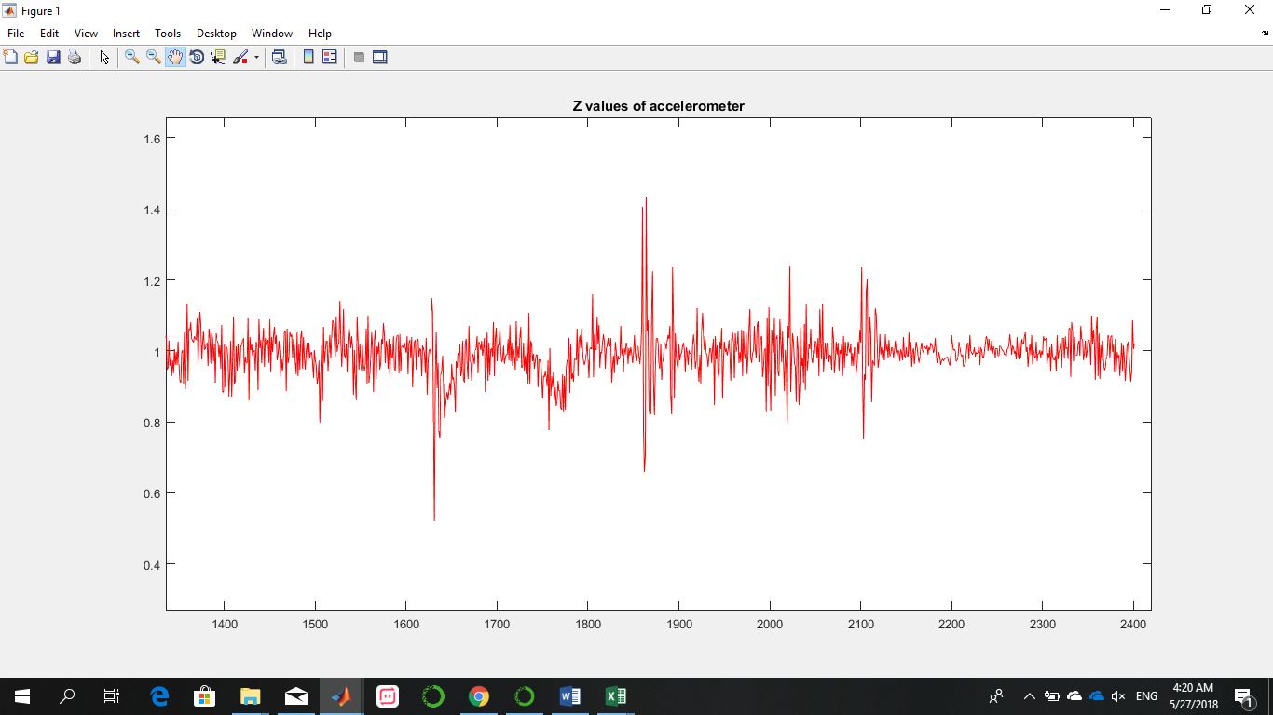

Figure 6.8 Z-axis Accelerometer signal for Reckless Speed Bump 1

### NEO 6MV2 GPS MODULE

In order to test the performance of the NEO 6MV2 GPS module, and check the ability to recording the coordinates of a car during a trip, we read data from the GPS module in multiple places, extracted the location coordinates (latitude and longitude), and inserted it to google maps to check and compare results:

This process was done more than 20 times in order to make sure that the location of the events is calculated correctly. Table 6.5 shows examples of three different locations that were captured using GPS module and their corresponding results from google maps at the same place and time, in addition to the map of that location.

Table 6.5 MLP testing of NEO6MV2 GPS

|  |  |  |  |  |  |
| --- | --- | --- | --- | --- | --- |
| location | Coordinates from GPS | | Coordinates from google maps | | Result in google maps |
|  | Latitude | Longitude | Latitude | Longitude |  |
| Location 1 | 25.321896 | 51.498179 | 25.321897 | 51.498168 |  |
| Location 2 | 25.374390 | 51.489768 | 25.374384 | 51.489761 |  |
| Location 3 | 25.335553 | 51.466875 | 25.335551 | 51.466869 |  |

It is clear from the table that coordinated of the GPS and google maps of a specific location are almost the same.

### Segmentation:

To test this part, a series of trips were performed and the number of events occurring in every trip was recorded. The segmentation algorithm should be able to correctly identify these events and extract their features. For testing purposes, the segmented events were graphed to ensure correct segmentation. The table below summarizes the results of the tests done.

Table 6.6 Segmentation Tests

|  |  |  |  |
| --- | --- | --- | --- |
| Trip Number | 5-minute Duration | Real Number of Events | Segmented Events |
| 1 | 1st | 13 | 12 |
| 1 | 2nd | 21 | 21 |
| 2 | 1st | 21 | 20 |
| 2 | 2nd | 9 | 8 |
| 3 | 1st | 22 | 22 |
| 4 | 1st | 19 | 18 |
| 4 | 2nd | 4 | 4 |
| 4 | 3rd | 20 | 19 |

### Classification:

There are 3 classifiers implemented in this system; MLP, SVM, RF. All classifiers were trained with the same data. After exporting the trained model for each classifier, the models are tested in this section with newly recorded 39 events of different type. 9 of these events are sudden brakes, 12 Left turns, 10 right turn, and 10 speed bumps. Table 6.7 shows the total number of recognized events and a comparison between the results of voting vs the actual labels.

Table 6.7 Event type Classifiers Output Vs Actual Event

|  |  |  |  |
| --- | --- | --- | --- |
| Sudden Brake | Left Turn | Right Turn | Speed Bump |
| SVM | 1 | 11 | 11 | 10 |
| MLP | 1 | 9 | 11 | 10 |
| RF | 7 | 10 | 9 | 10 |
| Voting Result: | 1 | 11 | 11 | 10 |
| Actual number | 9 | 10 | 10 | 10 |

Another experiment has been carried to test reckless/ safe classifiers. A number of 40 events were saved into a dataset, 29 reckless, and 11 safe events. Table 6.8 shows the output of the predictions.

Table 6.8 Reckless/ safe Classifiers output Vs Actual Event

|  |  |  |  |
| --- | --- | --- | --- |
| Sudden Brake | Left Turn | Right Turn | Speed Bump |
| SVM | 1 | 3 | 9 | 10 |
| MLP | 1 | 3 | 8 | 10 |
| RF | 7 | 3 | 8 | 10 |
| Voting Result: | 1 | 3 | 9 | 10 |
| Actual number | 9 | 3 | 9 | 10 |

### Integration Testing

#### Scenario

To test the whole system, we implemented a real scenario where the driver’s trips are recorded using the sensors data and each 5-minutes are segmented. As per the functional requirements, the data should be recorded constantly and segmented in real-time. For comparisons and testing purposes, during those trips, all events are manually labeled by us along with their timestamps. Events include turns, reckless turns, speed bumps, reckless speed bumps and sudden brakes. The features of the segments are then sent to the classifier through our server. The manual labels will help us test these events after classification and measure the accuracies of the segmentation and the classifiers.

#### Data collected

The project is placed in the car. The positive x-axis is in the right direction, positive y-axis in the forward direction and positive z-axis upwards. The data collected from the recorded events are the date, time, acceleration in all three axis, gyroscope in all three axis and the location data (longitude, latitude). An example of the recorded data is shown in the table below.

#### Testing process

For the events recorded, we aimed to record a variety of events. The Raspberry Pi stated recording the data just as the car was turned on. The segmentation and feature extraction, as mentioned earlier, were done of every 5 minutes of recorded data. An example of the segmentation done is shown in Figures 6.9, 6.10, and 6.11. This figures show the segmentation on the same duration done on all three-axis. A sample of the features extracted is shown in Figure 6.13.



Figure 6.9 Segmentation on x-axis



Figure 6.10 Segmentation on y-axis



Figure 6.11 Segmentation on z-axis

The total number of events recorded is 117 events. All these events were manually recorded along with their characteristics. After the trips are over, and the classification is done, the manually recorded data are compared with the classification results shown in the next section.

#### Testing results

Table 6.9 Testing Results

|  |  |  |  |  |  |
| --- | --- | --- | --- | --- | --- |
| File | Events | Actual Events | Segmented | Classified | notes |
| 0 | right turn | 0 | 0 | 0 |  |
| reckless right turn | 0 | 0 | 0 |  |
| left turn | 0 | 0 | 0 |  |
| speed bump | 0 | 0 | 0 |  |
| 1 | right turn | 6 | 6 | 7 | 1 Reckless: classified |
| left turn | 2 | 2 | 2 |  |
| sudden brake | 0 | 0 | 0 |  |
| speed bump | 16 | 16 | 15 |  |
| 2 | right turn | 11 | 11 | 12 |  |
| left turn | 4 | 4 | 4 |  |
| sudden brake | 3 | 3 | 1 |  |
| speed bump | 6 | 6 | 4 | 2 Reckless: 1 classified |
| 3 | right turn | 6 | 6 | 4 |  |
| left turn | 5 | 5 | 5 |  |
| sudden brake | 1 | 1 | 0 |  |
| speed bump | 9 | 9 | 7 | 2 Reckless: 1 classified |
| 4 | right turn | 12 | 12 |  | 3 Reckless: 8 classified |
| left turn | 4 | 4 | 4 |  |
| sudden brake | 2 | 2 | 4 |  |
| speed bump | 6 | 6 | 6 |  |
| 5 | right turn | 9 | 9 | 8 | 1 Reckless: 4 classified |
| left turn | 6 | 6 | 5 |  |
| sudden brake | 1 | 1 | 1 |  |
| speed bump | 8 | 8 | 6 | 2 Reckless: 1 classified |

#### Results Discussion

A sample output of the classifier for file number 5 is shown in Figure 6.12. As shown in Table 6.9 8 out of the 9 right turns are detected by the classifiers, 5 out of 6 left turns are detected, the one sudden brake and 6 out of 8 speed bumps are also detected by the classifier. For this particular example, the accuracies are 88.8%, 83%, 100%, and 75% for the detection of right turns, left turns, sudden brake, and speed bumps respectively.

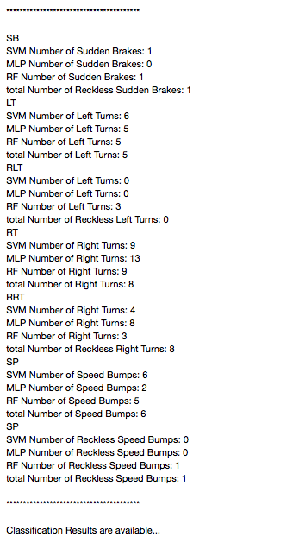

Figure 6.12 Screenshot of classifier output

In the second layer of classification, each event type is classified as either reckless or not. We can see that even though only 1 reckless right turn is done, 4 out of the total number of right turns are classified as reckless. This is mostly because recklessness is subjective, and the classifier’s measure of recklessness is different than individuals’ measures. The accuracy of training the right turn reckless classifier is 84%. This is only an issue with the right turn reckless classifier since for other files, the reckless events detected are close to the real ones. In the same file, for example, two reckless speed bumps are done and one of them was classified as reckless. Moreover, in file number 2, the same thing happens. Two reckless speed bumps are done and one of them was classified as reckless.

Table 6.10 sample of recorded data

|  |  |  |  |  |  |  |  |  |  |  |  |  |
| --- | --- | --- | --- | --- | --- | --- | --- | --- | --- | --- | --- | --- |
| Month | Day | Hour | Minute | Seconds | Acc\_x | Acc\_y | Acc\_z | Gyro\_x | Gyro\_y | Gyro\_z | Lat | Lon |
| 5 | 24 | 21 | 54 | 42 | 0.088867 | 0.001221 | 1.030273 | -0.35878 | 0.030534 | 0.015267 | '1511' | '48263') |
| 5 | 24 | 21 | 54 | 42 | 0.087646 | 0.001465 | 0.991211 | -0.43511 | 0.366412 | -0.03817 | '1531' | '55073') |
| 5 | 24 | 21 | 54 | 43 | 0.087891 | -0.02466 | 1.096924 | -0.84733 | 0.137405 | 0 | 'N05128.83420' | 'E2') |
| 5 | 24 | 21 | 54 | 43 | 0.070313 | -0.02686 | 1.059326 | -0.37405 | -0.09924 | -0.00763 | '1501' | '55305') |



Figure 6.13 Sample of Features Extracted

# Evaluation of the impact of the engineered solution

Table 7.1 Evaluation of the impact of the Engineered Solution

|  |  |  |  |
| --- | --- | --- | --- |
|  | Evaluation Context | Specific Contribution through the Project | level of impact (High, Medium, low |
| 1 | Global | This project will help ensure safe driving on roads and thus reduce car accidents. The statistics will help the ministry of interior know the places where the most reckless events happen and thus investigate these places and fix any issues if found.  This project will also lower the accident rate which will reduce the death rates that are caused by road accidents. | High |
| 2 | Economical | The components of the project are low-cost making the whole system affordable by individuals and associations.  The country already spends money to repair the damage caused by car accidents. In reducing the accidents rate, the project will in turn reduce the money spent by the government. | Medium |
| 3 | Environmental | There are no health, safety or any environmental impacts for this project. | Low |
| 4 | Societal | Classifying the driver behaviors and pointing out the reckless ones in order to assess drivers. This will help drivers observe their driving patterns and improve them. | High |

# Conclusion

In conclusion, our project was able to collect the kinematics of a moving car along with location information, segment the data and extract features. The segmentation algorithm was able to isolate all events that happened into their own segments which facilitated the classification process that took place in the next stage. It was also able to correctly classify the data first as event or no event with average accuracy of 82%. Then it classified the type of event as left turn, right turn, sudden brake or speed bumps with average accuracies of 89%, 89%, 85%, 86% respectively. Multiple classifiers were applied at each stage and a voting was done on their results in order to get the results with the highest accuracies. After the event type classification, another level of classification is applied to detect whether each event was reckless or not. The results were then available to the user on our website after he/she logs in using the Raspberry Pi ID and password. The user would see all the events in the previous trip along with when and where they occurred.

* Providing good experience for parking
* Able to simulate how parking resources could be managing

# Future work

This project addressed the problem of reckless driving. It was able to identify four types of events and whether or not they are reckless. There is still a huge area of improvement in the future. Examples of features to be added are:

1. Classify more types of events such as changing lanes and acceleration
2. Have the classification on the Raspberry Pi to make the system more scalable
3. Notify the driver when a reckless event occurs, either through sound or vibration
4. Establish a recklessness metric to tell exactly how much the driver is reckless

Basically, the main thing this project can improve in is in the classification part. Adding more event types require more data gathering and analysis of different driving patterns. It also requires more training for identifying these types of events.

# Student reflections

## Somayya Elmoghazy

This project was a very new experience for me. I had to learn different programming languages than the ones I know and be able to use them simultaneously. I also had to convert codes from one language to other which meant I had to understand the environment of these languages well.

However, the newest experience I had with this project was the introduction to machine learning and data gathering. We had to collect our own data while driving. This process became exhausting since it was our first experience with gathering data and had to repeat the data collected many times before we got the hang of it. Being the driver in the group, it meant I had to drive for many hours throughout this year only for the purpose of data collection.

Moreover, being in a team with both CS and CE students enabled us to explore both fields and to effectively distribute the work. However, although each focused on their field, we also got to learn more about the other field. I learned Node Js and javascript even though I never studied them and got to know more about web development.

All in all, I gained many new skills throughout this project that will definitely help me in my future career. The area of machine learning if vast and is there is always a room for improvement which will perhaps open new roads for me.

## Mareim Elsayem

In this project I was introduced for the first time to machine learning. I was able to learn a lot about different classifiers and how to apply them. I used multiple types of classifiers for classification and got learned the difference between them. This project also introduced me to the area of data analysis since we had to collect our own dataset for training. I’ve learned how to conduct the data reading process and how to organize data in order to be able to train the classifier with them.

Also, since I was with CE students in the team, I’ve learned more about hardware connections and how to interface sensors with the raspberry Pi. This are completely new to me and I’m glad I was able to learn it unlike many CS students.

In conclusion, this project I was introduced to many new areas. I’m mostly excited to learn more about machine learning.

## Diana Alworaydat

I believe that senior project is the reflection of everything a student can learn during study years, it not only about the academic information, it includes group working sills, communication skills and time management skills.

I learnt so many new things during the working time on this project.

The purpose of our senior project was detecting reckless driving behavior using machine learning algorithms multiple hardware and software components.

At this point I can’t say that working on it wasn’t easy at all it, it took a lot of work, time and effort.

At the end after one year of working we achieved our goal, got satisfying results and got new experiences and skills.

# References

References

1. "Road Crash Statistics", Asirt.org, 2017. [Online]. Available: http://asirt.org/initiatives/informing-road-users/road-safety-facts/road-crash-statistics. [Accessed: 09- Dec- 2017].
2. "MOI Qatar - News Article", Portal.moi.gov.qa, 2017. [Online]. Available: https://portal.moi.gov.qa/wps/portal/MOIInternet/mediacenter/moinews/!ut/p/a1/hc1BDoIwFATQs3iCTinBsiw12gIFDY1iN6Yr00TRhfH8folb9a9mkjf5LLCRhSk-0zk-0m2Kl3cPxak2KwsxoNm0hYAaWqczvQPyJYEjAatkbjh4Iw0kAV\_7qtcZwP\_tDyzMpCuheNkTkagorkXntp67PT7g14sZ4MspsPt1RLJq8QI4FM8W/?1dmy&page=pg.moi.newsdetails&urile=wcm%3Apath%3A%2Fwcmlib-internet-en%2Fsa-moinews%2F9e2e35f8-a6cb-4104-a0ba-5bdda30f91cd. [Accessed: 14- Nov- 2017].
3. “DRIVING IN QATAR,” DRIVING IN QATAR. BASELINE Trading Co., Doha, Qatar.
4. “Driving in Qatar,” Driving in Qatar | InterNations. [Online]. Available: https://www.internations.org/qatar-expats/guide/driving-in-qatar-15639. [Accessed: 20-Nov-2017].
5. S. Boonmee and P. Tangamchit, “Portable reckless driving detection system,” 2009 6th International Conference on Electrical Engineering/Electronics, Computer, Telecommunications and Information Technology, 2009.
6. Y. Zheng and J. H. Hansen, “Unsupervised driving performance assessment using free-positioned smartphones in vehicles,” 2016 IEEE 19th International Conference on Intelligent Transportation Systems (ITSC), 2016.
7. J. Dai, J. Teng, X. Bai, Z. Shen, and D. Xuan, “Mobile phone based drunk driving detection,” Proceedings of the 4th International ICST Conference on Pervasive Computing Technologies for Healthcare, 2010.
8. A. Zeeman and M. Booysen, “Combining speed and acceleration to detect reckless driving in the informal public transport industry,” 16th International IEEE Conference on Intelligent Transportation Systems (ITSC 2013), 2013.
9. A. Sathyanarayana, S. O. Sadjadi, and J. H. L. Hansen, “Automatic Maneuver Boundary Detection System for Naturalistic Driving Massive Corpora,” SAE International Journal of Passenger Cars - Electronic and Electrical Systems, vol. 7, no. 1, pp. 149–156, Jan. 2014.
10. M. Fazeen, B. Gozick, R. Dantu, M. Bhukhiya, and M. C. González, “Safe Driving Using Mobile Phones,” IEEE Transactions on Intelligent Transportation Systems, vol. 13, no. 3, pp. 1462–1468, Sep. 2012.
11. M. Wu, S. Zhang, and Y. Dong, “A Novel Model-Based Driving Behavior Recognition System Using Motion Sensors,” Sensors, vol. 16, no. 10, p. 1746, 2016.

1. V. Peddinti, D. Povey, and S. Khudanpur, “A time delay neural network architecture for efficient modeling of long temporal con- texts,” in Proc of INTERSPEECH, 2015, pp. 3214–3218.
2. M. Sugiyama, H. Sawai, and A. Waibel, “Review of TDNN (time delay neural network) architectures for speech recognition,” 1991., IEEE International Sympoisum on Circuits and Systems.
3. “Documentation,” Design Time Series Distributed Delay Neural Networks - MATLAB & Simulink. [Online]. Available: https://www.mathworks.com/help/nnet/ug/design-time-series-distributed-delay-neural-networks.html. [Accessed: 20-Dec-2017].
4. “filter,” Savitzky-Golay filtering - MATLAB sgolayfilt. [Online]. Available: https://www.mathworks.com/help/signal/ref/sgolayfilt.html. [Accessed: 20-Dec-2017].
5. K. Koscher, A. Czeskis, F. Roesner, S. Patel, T. Kohno, S. Checkoway, D. Mccoy, B. Kantor, D. Anderson, H. Shacham, and S. Savage, “Experimental Security Analysis of a Modern Automobile,” 2010 IEEE Symposium on Security and Privacy, 2010.
6. Keogh, E., Chu, S., Hart, D. and Pazzani, M. (2018). An Online Algorithm for Segmenting Time Series

# Appendix A – Project Plan

## A.1. Project milestones

|  |  |
| --- | --- |
| Milestones | Tasks |
| Information Gathering | 1. Research to prove the severity of the problem in Qatar    1. Interview government officials    2. Survey 2. Gather information about how driving in Qatar is viewed in different institutions and organizations 3. Research the already existing procedures in Qatar to identify reckless driving and their effectiveness 4. Research the possible machine learning algorithms that can be used for our project 5. Look for ways to initially collect data    1. Either design a simple APP or find an existing one 6. Analyze the collected data |
| Problem Definition and Project  Significance | 1. Find real statistics about road accidents and their causes in Qatar 2. Decide the technical and non-technical challenges for our project   List all the benefits of our project for both stakeholders and for the region in Qatar |
| Hardware and software to be used | 1. Search for all the possible hardware options    1. List them all in a table along with their features and costs 2. Analyze the possibilities and compare them with our requirements and budget   Make the decision on which components to use |
| Related Work | 1. Read and summarize multiple papers that approached the same problem using machine learning or any other methods 2. Analyze all the methods discussing the pros and cons of each 3. List the similarities and differences between our approach and the other approaches discussed |
| Requirement analysis | 1. Write down the functional requirements of our project 2. Decide on all the constraints 3. Design the use case diagram    1. Add a description of each use case    2. Do the use case specification for each use case 4. List the design standards 5. Code of ethics |
| Design | 1. Solution overview 2. Design flowchart of the system 3. Design high level architecture of the system |
| Interim Report | 1. Collect all the required information and the work done in the interim report 2. Revise the first draft of the report with the supervisor and get feedback 3. Submit the complete interim report |
| Software and hardware design | 1. Find algorithms    * 1. Find an algorithm to classify each type of all the events of the segmented data      2. Find multiple machine learning algorithms to classify each event whether it is reckless or not      3. Find algorithm to specify a recklessness scale for each event according to specific numeric matric 2. Design a website/mobile app to be an interface between the system and the user 3. Design a schematic diagram of the circuit (hardware components) |
| Hardware and software Implementation | 1. Connect Triple Axis Gyroscope & Accelerometer Module to the raspberry pi (hardwired) 2. Connect raspberry pi to the DAM (wirelessly) 3. Connect all helping hardware component to use raspberry pi 4. Add plates numbers and the corresponding passwords to the data base 5. Program the raspberry pi to detect any change in x, y and z axis and segment that data then send them to the DAM 6. Collect data to that will be used for training machine learning algorithms 7. Apply multiple algorithms on the DAM 8. To classify event type of segmented data 9. To classify each event whether it is reckless or not 10. To specify a recklessness scale for each event according to specific numeric matric 11. Implement a mobile app/website to be used by the user |
| Algorithms analysis | 1. Test multiple machine learning algorithms using new collected data 2. Find percentage error of the output for the tested data 3. Decide the best algorithm to be used in the system |
| Testing and Modification | 1. Collect more data of normal and reckless driving behaviors 2. Test the entire system 3. Find percentage error of the system’s output 4. modify and train the algorithm with more data to reduce the percentage error |
| Documentation | 1. Collect all the required information and the work done in the report 2. Revise the first draft of the report with the supervisor and get feedback 3. Submit the complete interim report |

## A.2. Project timeline

### Phase1

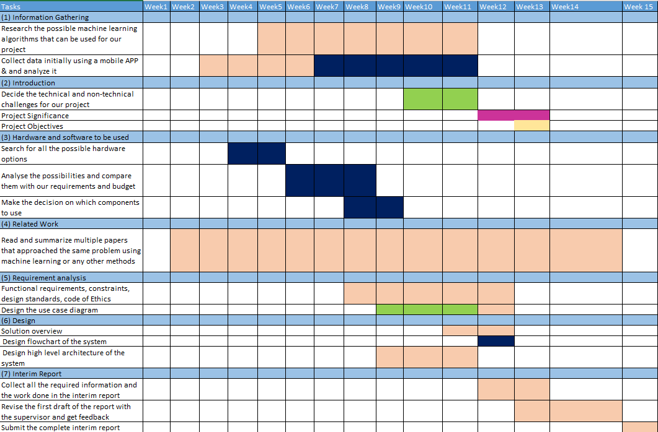

### Phase2

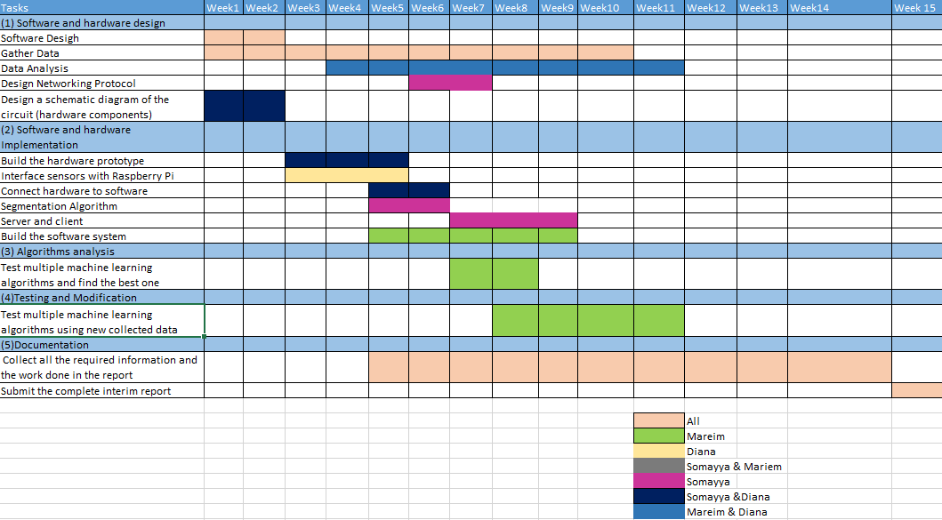

## A.3. Anticipated risks

Table 12.1 Risks and Contingency Plans

|  |  |  |
| --- | --- | --- |
| **Anticipated risks** |  | **Contingency Plan** |
| Not allowing human resources for data collection and testing. | 🡪 | Rely on our own collected data, and generating artificial signals. |
| Volunteers are not following our safety rules in data collection experiments. | 🡪 | Volunteers are to be forced to do the least of reckless behaviors. |
| Hardware component move from their fixed place, or any wire connected between the system’s component gets defected. | 🡪 | Hardware components are to be embedded and fixed in the cars, alternative Triple Axis Gyroscope & Accelerometer Module is used in case of any defection. |